



**System Requirement Specification**

**<Library Management System>**

Security Classification: **Confidential**

**Approval Page**

|  |  |  |  |  |
| --- | --- | --- | --- | --- |
|  | | | | |
| **Decision** | ☐ Approved ☐ Rejected |  |  |
| Name: |  |  |  |
| Signature/Date: |  |  |  |

Revision History

|  |  |  |  |
| --- | --- | --- | --- |
| Date | Version | Author | Change Description |
| 13/10/2022 | 0.1.0 | Group 01 | Introduction  - Purpose  - Glossary and Abbreviations  - Document Referenced |
| 14/10/2022 | 0.1.1 | Group 01 | High Level Requirements |
| 17/10/2022 | 0.1.2 | Group 01 | Use Case Diagram |
| 21/10/2022 | 0.1.3 | Group 01 | Use Case Catalogue: Request Borrow Book  - Overview  - Activity Flow |
| 24/10/2022 | 0.1.4 | Group 01 | Use Case Catalogue: Request Borrow Book  - Basic Flow  - Alternative Flow  - Exceptional Flow |
| 7/11/2022 | 0.1.5 | Group 01 | Use Case Catalogue: Request Borrow Book  - Mock-up Screen  - Screen Description |
| 10/11/2022 | 0.1.6 | Group 01 | Use Case Catalogue: Request Borrow Book  - Business Rules |
| 15/11/2022 | 0.2.1 | Le Huyen Linh | Use Case specification:  UC03. View Book Information |
| 15/11/2022 | 0.2.4 | Pham Thi Nhan | Use Case specification:  UC07: Request purchase book - overview |
| 16/11/2022 | 0.2.2 | Pham Minh Hoang | Use Case specification:  UC02. Search book |
| 17/11/2022 | 0.2.3 | Nguyen Thanh Thuy | Use Case specification:  UC08. Reserve Book |

Table of Contents

1. Introduction **7**

1.1.1 Purpose 7

1.2 Glossary and Abbreviations 9

1.3 Document Referenced 10

2. High Level Requirements **11**

2.1 High Level Business Process 11

2.2 Swimlane Diagram 12

2.3 Use Case Diagram 13

2.4 Actor 14

2.5 Use Case Catalogue 14

2.6 Site Map 15

3. Use Case Specifications **16**

3.1 UC01 <Request Borrow Book> 16

3.1.1 Overview. 16

3.1.2 Activity Flow 17

3.1.3 Flow of Events 17

3.1.3.1 Basic Flow 17

3.1.3.2 Alternative Flow - <Unavailable Book to reserve>. 18

3.1.3.3 Alternative Flow - <Unavailable Book to purchase>. 18

3.1.3.4 Alternative Flow - <Unavailable Book to cancel>. 18

3.1.3.5 Alternative Flow - <Return to previous screen>. 18

3.1.3.6 Alternative Flow - <Submit more than once>. 19

3.1.3.7 Alternative Flow - <Blank text note>. 19

3.1.3.8 Exceptional Flow - <No internet>. 19

3.1.3.9 Exceptional Flow - <Session Timeout>. 19

3.1.4 Mock-up Screen 20

3.1.5 Screen Description 25

3.1.6 Business Rules 36

3.2 UC02: <Search book > 37

3.2.1 Overview 37

3.2.2 Activity Flow 38

3.2.3 Flow of Events 38

3.2.3.1 Basic Flow 38

3.2.3.2 Alternative Flow - <No Data Found> 38

3.2.3.3 Alternative Flow - <Press Enter to search> 38

3.2.3.4 Alternative Flow - <Not Enter the keywords> 39

3.2.3.5 Exceptional Flow - <No internet connection> 39

3.2.4 Mock-up Screen 40

3.2.5 Screen Description 42

3.2.6 Business Rules 47

3.3 UC03: <View Book Information> 48

3.3.1 Overview 48

3.3.2 Activity Flow 48

3.3.3 Flow of Events 49

3.3.3.1 Basic Flow 49

3.3.3.2 Alternative Flow - Stop viewing information. 49

3.3.3.3 Exceptional Flow - <Session Timeout> 49

3.3.3.4 Exceptional Flow - <No Internet> 49

3.3.4 Mock-up Screen 50

3.3.5 Screen Description 51

3.3.6 Business Rules 52

3.4 UC04: <View Author Information> 53

3.4.1 Overview 53

3.4.2 Activity Flow 53

3.4.3 Flow of Events 53

3.4.3.1 Basic Flow 53

3.4.3.2 Alternative Flow - Stop viewing information. 53

3.4.3.3 Alternative Flow - View author from “Search" screen. 54

3.4.3.4 Exceptional Flow - <Session Timeout> 54

3.4.3.5 Exceptional Flow - <No Internet> 54

3.4.4 Mock-up Screen 54

3.4.5 Screen Description 55

3.4.6 Business Rules 55

3.5 UC05: <View All Editions> 56

3.5.1 Overview 56

3.5.2 Activity Flow 56

3.5.3 Flow of Events 56

3.5.3.1 Basic Flow 56

3.5.3.1.1 Alternative Flow - Stop viewing information. 56

3.5.3.2 Alternative Flow - Show data in tab bar. 56

3.5.3.3 Exceptional Flow - <Session Timeout> 57

3.5.3.4 Exceptional Flow - <No Internet> 57

3.5.4 Mock-up Screen 57

3.5.5 Screen Description 58

3.5.6 Business Rules 58

3.6 UC06: <Preview > 59

3.6.1 Overview 59

3.6.2 Activity Flow 59

3.6.3 Flow of Events 60

3.6.3.1 Basic Flow 60

3.6.3.2 Alternative Flow - Stop viewing information. 60

3.6.3.3 Alternative Flow - Stop previewing the book pages. 60

3.6.3.4 Exceptional Flow - <Session Timeout> 60

3.6.3.5 Exceptional Flow - <No Internet> 60

3.6.4 Mock-up Screen 61

3.6.5 Screen Description 62

3.6.6 Business Rules 63

3.7 UC07: <Request purchase book> 64

3.7.1 Overview 64

3.7.2 Activity Flow 65

3.7.3 Flow of Events 65

3.7.3.1 Basic Flow 65

3.7.3.1.1 Alternative Flow - Unavailable book - Request reserve case 66

3.7.3.1.2 Alternative Flow - Unavailable book - Click “X” to cancel 66

3.7.3.1.3 Exceptional Flow - <No Internet> 66

3.7.3.1.4 Exceptional Flow - <Session Timeout> 66

3.7.3.1.5 Exceptional Flow - <Server overload> 66

3.7.3.2 Mock-up Screen 67

3.7.3.3 Screen Description 69

3.7.3.4 Business Rules 72

3.8 UC08: <Reserve Book> 73

3.8.1 Overview 73

3.8.2 Activity Flow 74

3.8.3 Flow of Events 75

3.8.3.1 Basic Flow 75

3.8.3.2 Alternative Flow - Unavailable book - Request purchase case 75

3.8.3.3 Alternative Flow - Available book - Request borrow case 75

3.8.3.4 Alternative Flow - Unavailable book - Click “X” to cancel 75

3.8.3.5 Alternative Flow - Do not select Pick up Location 75

3.8.3.6 Alternative Flow - Do not input Expiry Date 76

3.8.3.7 Alternative Flow - Do not input Expiry Date & Pick up Location 76

3.8.3.8 Exceptional Flow - <No Internet> 76

3.8.3.9 Exceptional Flow - <Session Timeout> 76

3.8.3.10 Exceptional Flow - <Server overload> 76

3.8.4 Mock-up Screen 78

3.8.5 Screen Description 82

3.8.6 Business Rules 86

3.9 UC09: <Approve/ Reject purchase book> 88

3.9.1 Overview 88

3.9.2 Activity Flow 89

3.9.3 Flow of Events 89

3.9.3.1 Basic Flow 89

3.9.3.2 Alternative Flow – Reject the “request for purchase book” 90

3.9.3.3 Alternative Flow – Reject the “request for purchase book” 90

3.9.3.4 Alternative Flow – Approve once time for one book 90

3.9.3.5 Exceptional Flow - <Session Timeout> 90

3.9.3.6 Exceptional Flow - <No Internet> 91

3.9.4 Mock-up Screen 91

3.9.5 Screen Description 94

3.9.6 Business Rules 99

4. Appendices **101**

4.1 Message List 101

4.1.1 Success Message 101

4.1.2 Error Message 101

4.2 Email List 102

4.2.1 ET 1: Sending email to Customer for successful borrowing request. 102

4.2.2 ET 2: Sending email to Customer for successful reservation. 103

4.2.3 ET 3: Sending email to Customer for successful purchase. 104

# Introduction

## Purpose

The purpose of the document is to collect and analyse all assorted ideas that have come up to define the system, its requirements with respect to consumers. Also, we shall predict and sort out how we hope this product will be used to gain a better understanding of the project, outline concepts that may be developed later, and document ideas that are being considered, but may be discarded as the product develops.

LiMS software is designed to help library managers and students/faculty optimise processes, convenience, and intelligent applications in methods of using resources in the library. The objective of LiMS is an online system which is used in the internal of University, it provides various functionalities for user/admin around using (borrow/reserve/ purchase) & managing (adding/delete) books. Further the library staff personnel/admin can add/update/remove the resources and the resource users from the system.

**The Feature of Admin/ Librarian/Student or Teacher in these system:**

Librarian:

* Searching a book

- Adding/Deleting book in system

- Exporting the statistic of related in book/viewer

- Approval/Reject request purchase a book

Admin: (Including features of Librarian & Student, Teacher)

* Adding/Active/Inactive account
* View/Edit the information of account/book
* Interfering in user action to fix/change information

Student and Teacher:

- View the List of books in each category

- Own an account in the library

- View the history of books issued to her/him previously

- Search for a book

- Borrow a book/ Reserve a book that is not available/ Request to purchase a book that has not been exist

- Cancel their reservation

**Product Non-functional Requirements**

- Performance Requirement

- Safety Requirement

- Security Requirement

- Usability requirement:

**Scope of Project:**

The Scope of work links with the contract mentioned, these projects will take place in 4 months and are expected to Go-live in March 2023 *(If there are no objective problems or subjective opinions from the customer).* The Detail of timeline will be specified in Appendix 1.

Project team includes 1 PM, 2 BA, 2 DEV, 1 Tester *(Specific information in Appendix 1)* to build up the system and responsibility of warranty and also support customer needs (training/fixing) after Go-live in 2 months *(based on the function that has been built and not outside the scope of project).*

## Glossary and Abbreviations

|  |  |
| --- | --- |
| Acronym | Reference |
| SRS | System Requirement Specification |
| UC | Use Case |
| BRL | Business Rules |
| ET | Email Template |
| MSG | Message |
| SMSG | Success Message |
| EMSG | Error message |
| [Field] | Convention for mentioning a field |
| “Text Value” | Convention for mentioning a value |
| N/A | Not Available |
| LiMS | Library Management System |
| BB | Borrow book |
| VB | View book |
| RB | Reserve book |
| PB | Preview book |
| VA | View Author |
| VE | View Editions |

## Document Referenced

|  |  |
| --- | --- |
| Attachment | Document Name / Title |
| [Slide BAF](https://drive.google.com/drive/folders/1azgXakgUbdeZ8MEplN43nLXpQe119wpk?usp=sharing) | High Level Requirement Slide |
| [High level wireframes](https://www.bing.com/images/search?view=detailV2&ccid=rbbWIEHF&id=C7E067AD0F849CF3E250421E9CEC4DAE5387EBFE&thid=OIP.rbbWIEHFkHr131Js84JlxQHaE8&mediaurl=https%3a%2f%2fdesign101idm.files.wordpress.com%2f2020%2f04%2fapp-wireframe-annotated-optimised.png%3fw%3d2048&cdnurl=https%3a%2f%2fth.bing.com%2fth%2fid%2fR.adb6d62041c5907af5df526cf38265c5%3frik%3d%252fuuHU65N7JweQg%26pid%3dImgRaw%26r%3d0&exph=1369&expw=2048&q=high+level+wireframes&simid=608043975228271585&FORM=IRPRST&ck=6C4CDF009EF41FDDBD7A6CB52B957F67&selectedIndex=14&ajaxhist=0&ajaxserp=0) | High Level Wireframes |
| [SRS template 4.0](https://docs.google.com/document/d/1ScBIQapirWVyrX_w-_ZcZZAtkIA0ciLU/edit#heading=h.1ksv4uv) | SRS template |
| [LIMS_Process & Functions.docx](https://docs.google.com/document/d/18nSELz99AyvD6j5egLz3upOR0v6KkRKG/edit) | LiMS-Process & Functions |
| [Use case specification - Thinh notes.](https://thinhnotes.com/chuyen-nghe-ba/viet-dac-ta-use-case-sao-don-gian-nhung-hieu-qua/) | Use case specification |
| [G1- BA - LiMS.xlsx](https://docs.google.com/spreadsheets/d/1Yqf9bySrh9Nq_kNz8cXmRtuSjohuF-jH/edit#gid=632362697) | Elicitation plan and Q&A Materials |

# High Level Requirements

This section describes the general overview of the system functions or business processes which are depicted in different diagrams. It shows the types of users, their granted permissions to perform specific system functions and the sequence required to complete a business workflow (if any). As the section name implies, it is high-level which means not detailed enough. For detailed requirement specification, please see Use Case Specifications section below.

## High Level Business Process

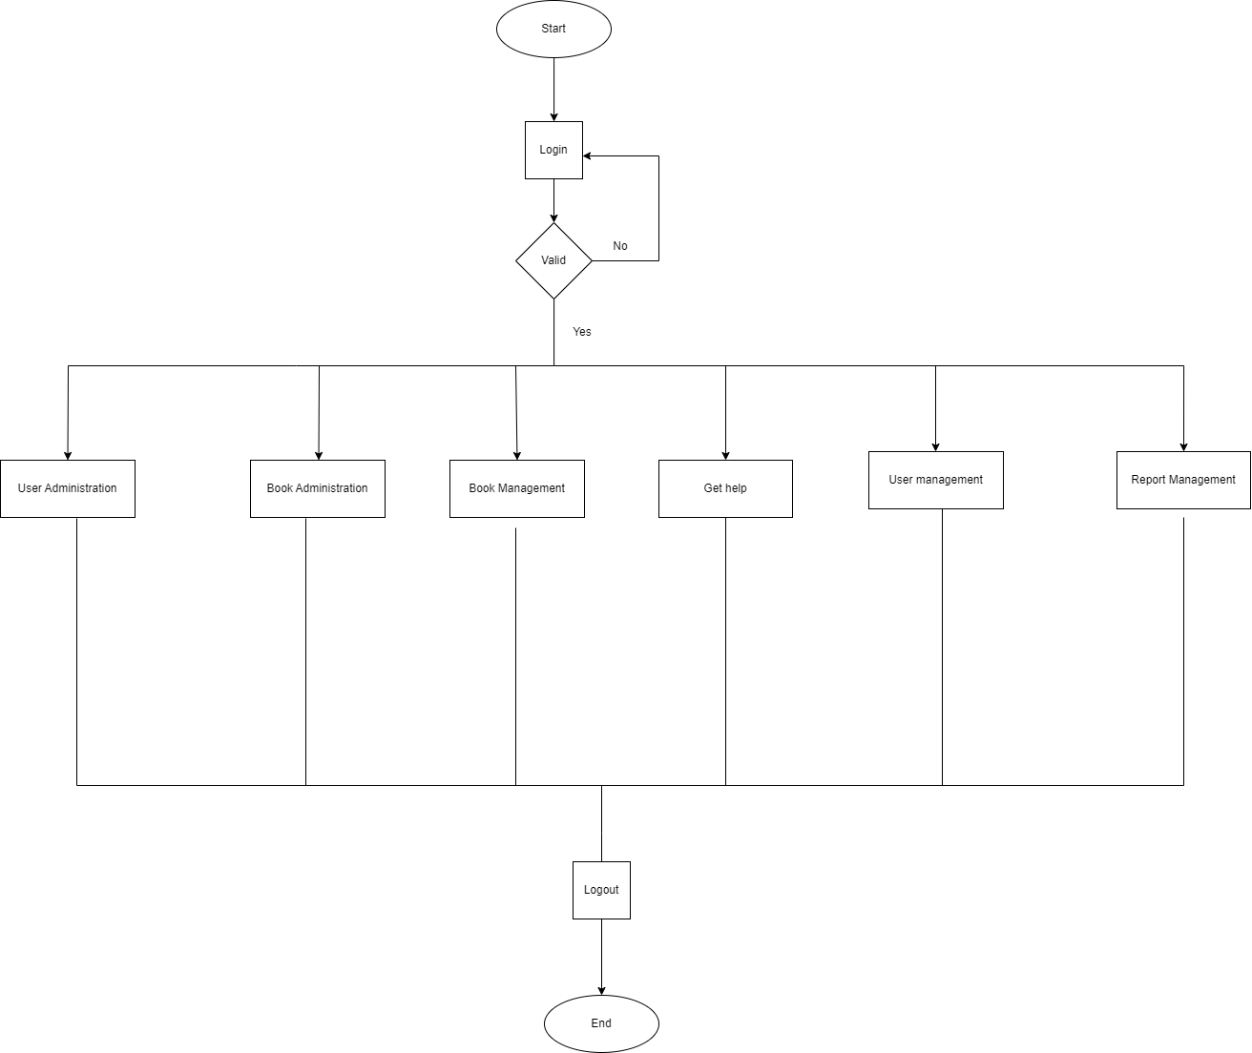

PROCESS-02: FLOW CHART LiMS - HIGH LEVEL BUSINESS

## Swimlane Diagram

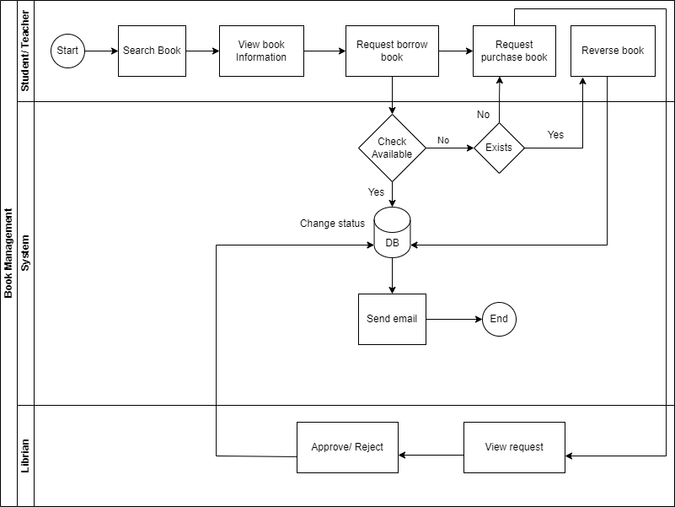

PROCESS-03: SWIMLANE LiMS-BOOK MANAGEMENT

## Use Case Diagram

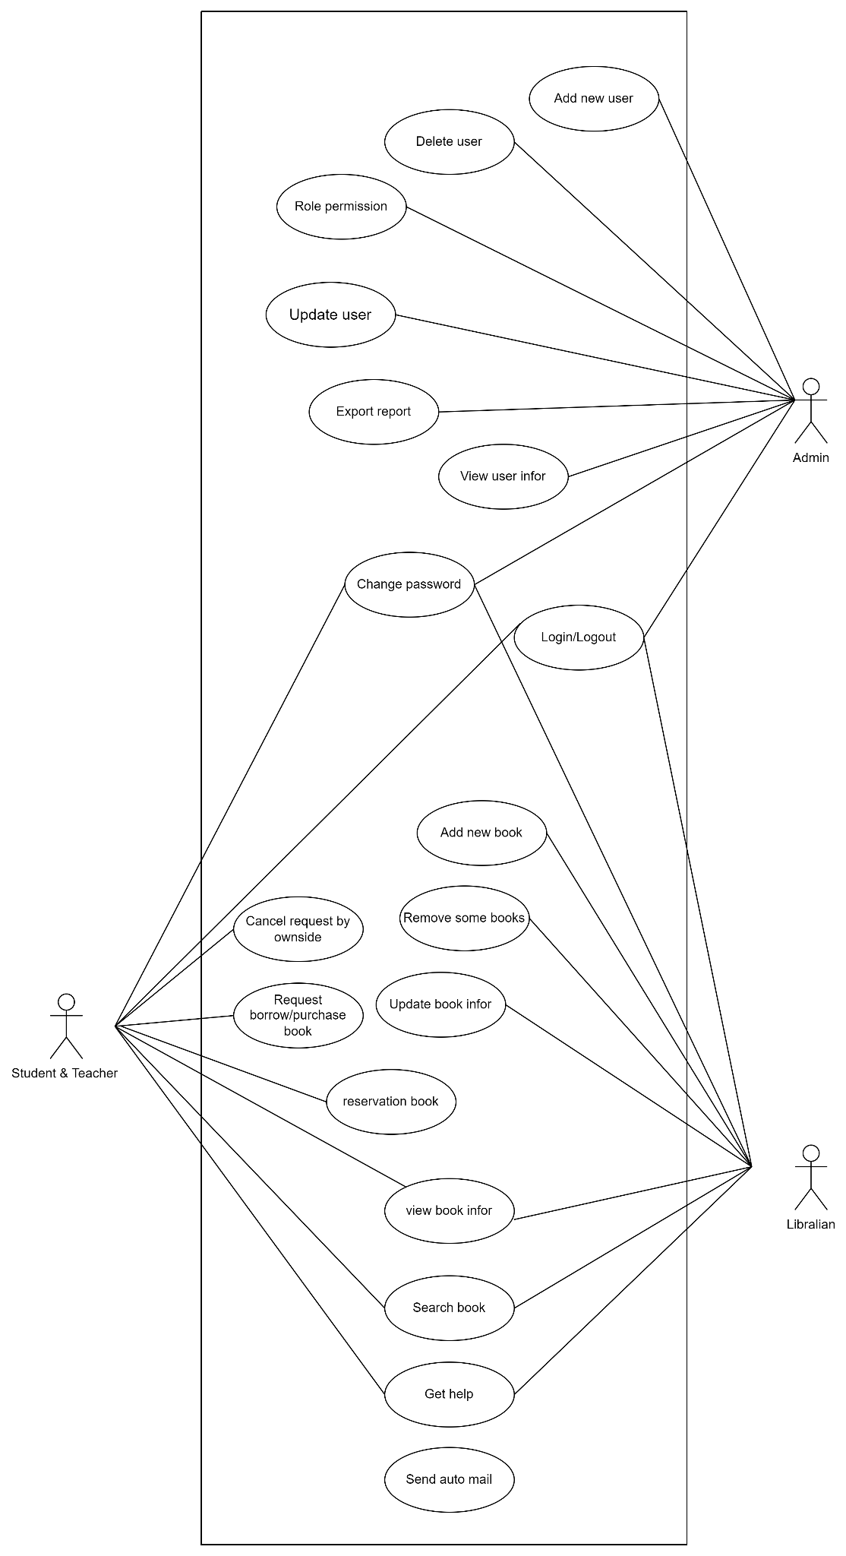

PROCESS-04: USE CASE DIAGRAM LiMS - HIGH LEVEL BUSINESS

## Actor

|  |  |
| --- | --- |
| actor | Description |
| Student | User of the system who can send request of ‘borrow /purchase/reserve book and cancel the request |
| Teacher | User of the system who can send request of ‘borrow /purchase/reserve book and cancel the request |
| Librarian | Person who decentralised to approve or reject request from students and teachers, add new book, delete book |
| Administrator | Admin can use system to import/export the report, active & inactive account, add create new account |

## Use Case Catalogue

* + 1. User Administration

|  |  |  |
| --- | --- | --- |
| UC ID | UC Name | Description |
| UC01.1 | Add new user | This Use Case allows admin to add new user to the database in the LiMS |
| UC01.2 | Update user | This Use Case allows admin to update and change student and teacher profile to the database in LiMS |
| UC01.3 | Delete user | The Use Case allows admin to deactivate user’s account in database in the LiMS |
| UC01.4 | Role permission | This Use Case allows admin to divide different roles to user with limited action for each role in the LiMS |

* + 1. Book management

|  |  |  |
| --- | --- | --- |
| UC ID | UC Name | Description |
| UC01 | Request Borrow Book | This Use Case allows student and teacher to place book borrowing request in the LiMS |
| UC02 | Search Book | This Use Case allows student and teacher to search book in the LiMS |
| UC03 | View Book Information | The Use Case allows student and teacher to view information of each book in the LiMS |
| UC07 | Request Purchase Book | This Use Case allows student and teacher to request library to update new book in order to borrow it |
| UC08 | Reserve Book | This Use Case allows student and teacher to reserve book in the LiMS |
| UC09 | Approve/ Reject Book | The Use Case allows librarians to approve or reject the borrow, reserve and purchase request in the LiMS |

* + 1. Book administration

|  |  |  |
| --- | --- | --- |
| UC ID | UC Name | Description |
| UC03.1 | Add new book | This Use case allows librarian to add new book information to database in the LiMS |
| UC03.2 | Remove some books | This Use case allows librarian to delete book from database in the LiMS |
| UC03.3 | Update book information | This Use case allows librarian to update and change book information to database in the LiMS |

* + 1. User management

|  |  |  |
| --- | --- | --- |
| UC ID | UC Name | Description |
| UC04.1 | Authenticate | This Use Case allows users to authenticate their accounts in the LiMS |
| UC04.2 | View user information | This Use Case allows user to view his own account information and other’s information within his role’s permission in the LiMS |
| UC04.3 | Change password | The Use Case allows user to change account’s password in the LiMS |

* + 1. Report management

|  |  |  |
| --- | --- | --- |
| UC ID | UC Name | Description |
| UC05.1 | Export Report “Lent books” | This Use case allows librarian to get list of books that have been lent though the time in the LiMS |
| UC05.2 | Export Report “Returned books” | This Use case allows librarian to get list of returned books in the LiMS |
| UC05.3 | Export Report “Late return account” | This Use case allows librarian to get list of accounts that have returned late in the LiMS |

## Site Map

<The site map describes the way for navigating through the system. (Optional)>

# Use Case Specifications

This section covers the system’s functional requirements which details what the system must do in terms of input, behaviour and the expected output. It elicits the interaction between the actor(s) and the system, the system’s behaviour and the results of their interactions.

## UC01 <Request Borrow Book>

##### Overview.

|  |  |
| --- | --- |
| ID and Name | UC01 - Request Borrow Book |
| Description | Allow student and teacher borrow any books in LiMS by their accounts |
| Actor | Student/Teacher |
| Trigger | After login student or teacher, click on “Borrow book” button on any book |
| Pre-condition | Books which student or teacher request to borrow are available,  (All of the books are not borrowed by others) |
| Post-condition | - Send email request borrow successfully and change status of this book in database  - The number of borrowed books decreased.  - Message is displayed that “Your request has been sent successfully! Check your email to see details.” |

##### Activity Flow

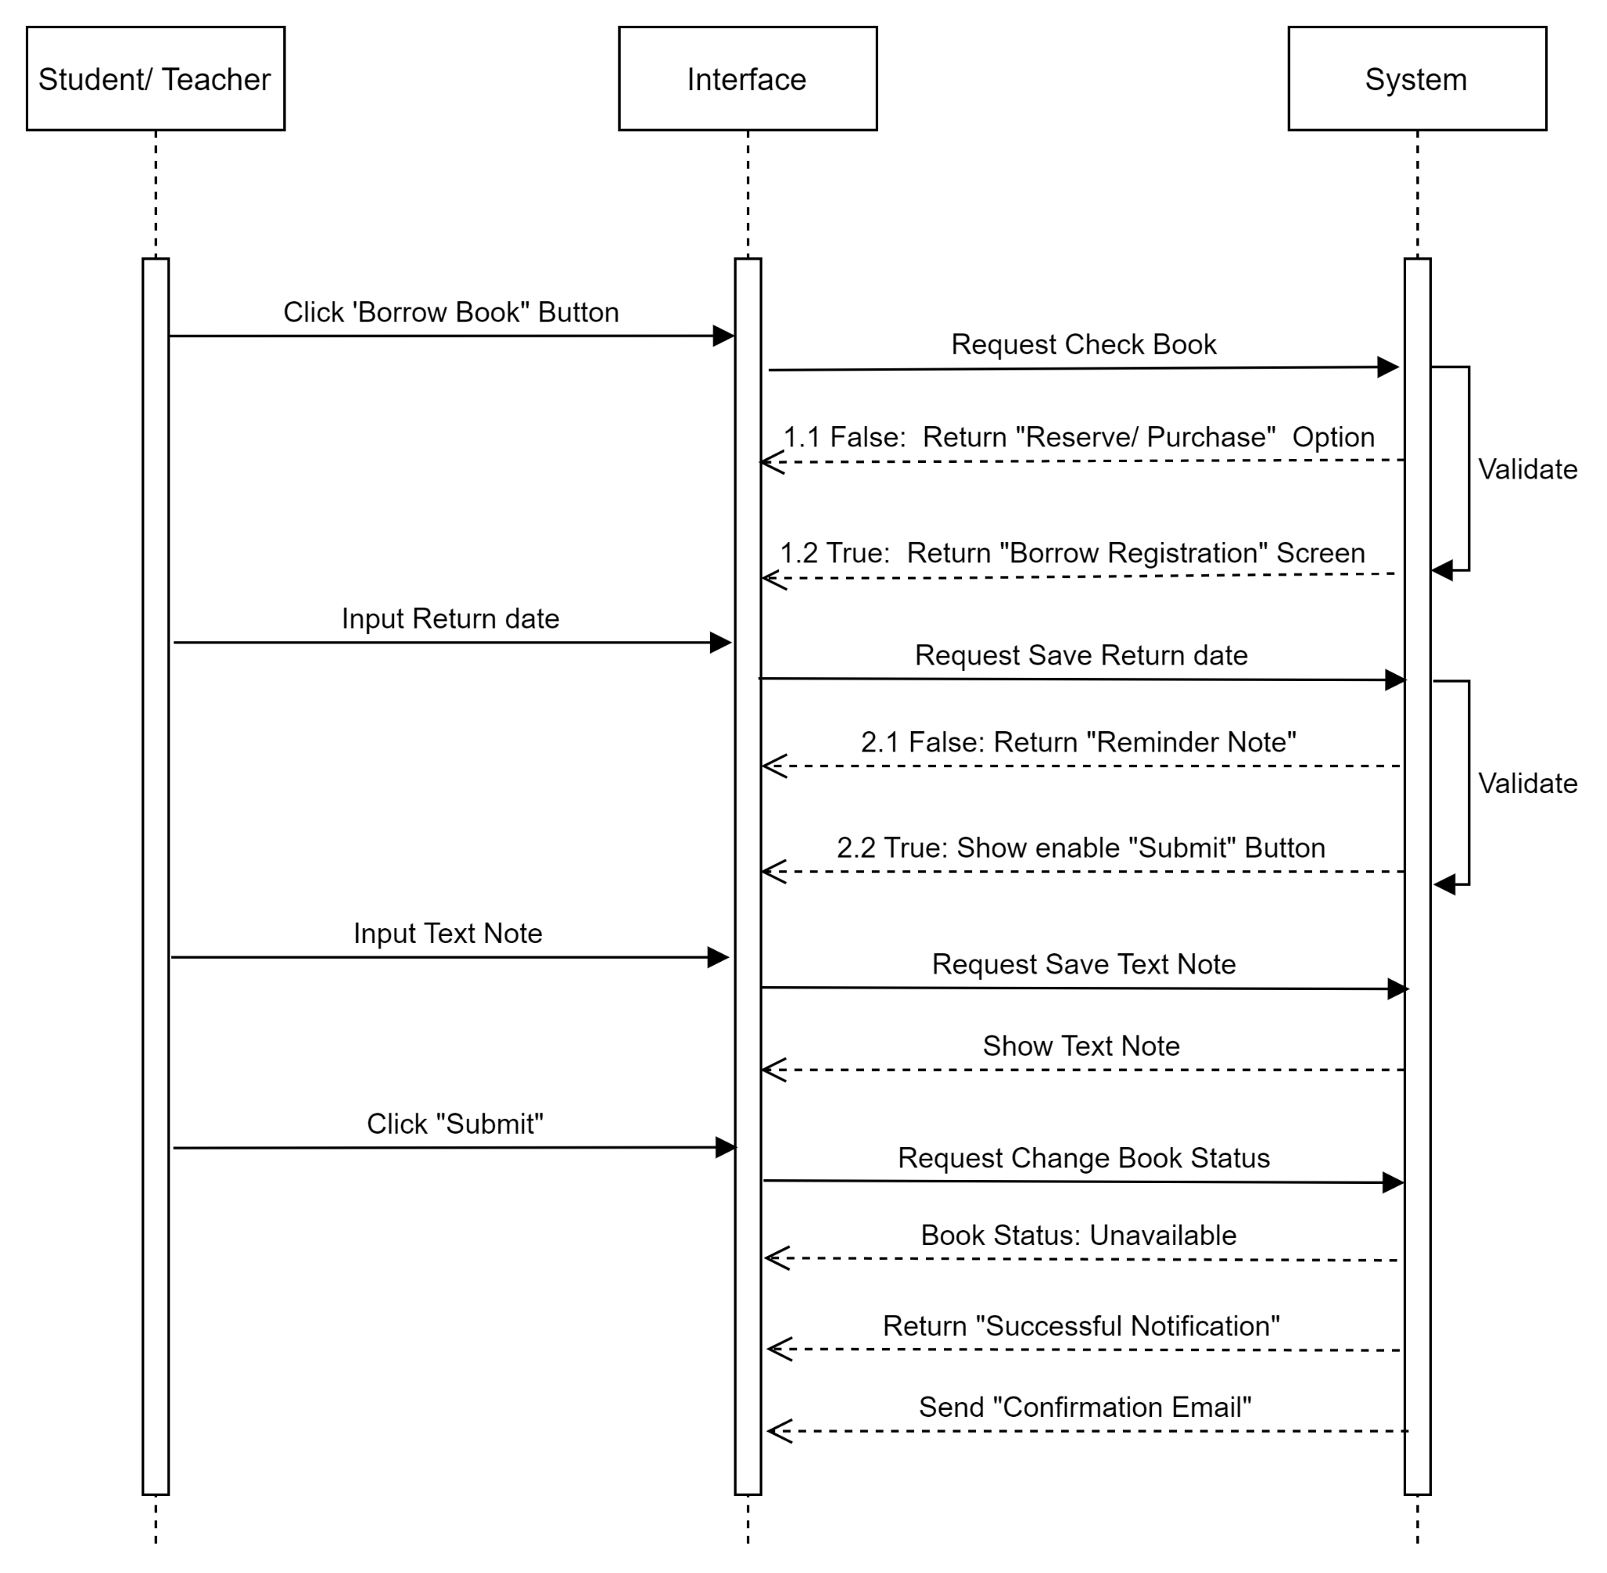

FC01. ACTIVITY FLOW- BORROW BOOK

##### Flow of Events

#### Basic Flow

| Step | Description |
| --- | --- |
| 1. | Actor clicks the ‘Borrow Book' button on the book they want to borrow on the “View Information Book” screen. |
| 2. | LiMS checks the book’s status through the database. LiMS displays screen: ‘Borrow Registration” |
| 3. | Actor inputs a return date on “Return Date Field”. Screen displays return date input. |
| 4. | Actor inputs some notes. Screen displays text note input. |
| 5 | Actor clicks on the ‘Submit’ Button. |
| 6. | LiMS displays success notification SMSG1 |

#### Alternative Flow - <Unavailable Book to reserve>.

**Continued from Step #1 in the Basic Flow:**

| Step | Description |
| --- | --- |
| 1 | LiMS checks the book’s status through the database. If the book is unavailable, LiMS displays the notification:  “ Status: Unavailable  This book has already been borrowed by other students!” |
| 2 | Actor clicks on the “Reserve’’ button when the actor wants to reverse the book. |

#### Alternative Flow - <Unavailable Book to purchase>.

**Continued from Step #1 in the Basic Flow:**

| Step | Description |
| --- | --- |
| 1 | LiMS checks the book’s status through the database. If the book is unavailable, LiMS displays the notification:  “ Status: Unavailable  This book has already been borrowed by other students!” |
| 2 | Actor clicks on the “Purchase’’ button when the actor wants to reverse the book. |

#### Alternative Flow - <Unavailable Book to cancel>.

**Continued from Step #1 in the Basic Flow:**

| Step | Description |
| --- | --- |
| 1 | LiMS checks the book’s status through the database. If the book is unavailable, LiMS displays the notification:  “Status: Unavailable  This book has already been borrowed by other students!” |
| 2 | Actor clicks the button “x”. LiMS displays the page “View Book Information”. |

#### Alternative Flow - <Return to previous screen>.

**Continued from Step #2,#3,#4 in the Basic Flow:**

| Step | Description |
| --- | --- |
| 1 | The actor clicks on  button. |
| 2 | LiMS displays the page “View Book Information”. |

#### Alternative Flow - <Submit more than once>.

**Continued from Step #6 in the Basic Flow:**

|  |  |
| --- | --- |
| Step | Description |
| 1 | Actor turns back to “View Book Information” screen that actor send borrow request. |
| 2. | LiMS checks the book’s status through the database. LiMS displays screen: ‘Borrow Registration” |
| 3. | Actor inputs a return date on “Return Date Field”. Screen displays return date input. |
| 4. | Actor inputs some notes. Screen displays text note input. |
| 5 | Actor clicks on the ‘Submit’ Button. |
| 6 | LiMS displays message: EMGS4 |

#### Alternative Flow - <Blank text note>.

**Continued from Step #4 in the Basic Flow:**

| Step | Description |
| --- | --- |
| 1 | The actor doesn’t input any notes. |
| 2 | Actor clicks on the ‘Submit’ Button. |
| 3 | LiMS displays success notification SMSG1 |

#### Exceptional Flow - <No internet>.

**Continued from Step #1,#2,#3,#4,#5,#6 in the Basic Flow:**

|  |  |
| --- | --- |
| Step | Description |
| 1 | Unplug the wifi routine or internet cable wire from the computer. |
| 2 | Screen display informational message EMGS3. |

#### Exceptional Flow - <Session Timeout>.

**Continued from step #5 in the Basic Flow:**

|  |  |
| --- | --- |
| Step | Description |
| 1 | Actor doesn’t interact with “Borrow Book” screen for more than 15 minutes |
| 2 | The message will appear automatically on EMGS6 and the actor must login again. |

##### Mock-up Screen

|  |  |
| --- | --- |
| BB1.1. View Book Information |  |
| BB1.2.View Book Information - Views all editions |  |
| BB1.3.1.View author |  |
| BB.1.3.2.View author’s details |  |
| BB 2.1.1.Borrow Registration - Return date tooltip |  |
| BB 2.1.2.Borrow Registration - Return date reminder note |  |
| BB 2.1.3.Borrow Registration - Select return date |  |
| BB 2.1.4.Borrow Registration - Success Notification |  |
| BB 2.1.5. Book borrow - Confirmation Email |  |
| BB 2.2 Book borrow - Reserve/ Purchase Option |  |

##### Screen Description

BB-Header

| REF | Field Name | Control Type | Data Type | Default Value | Mandatory | Editable | Description |
| --- | --- | --- | --- | --- | --- | --- | --- |
| 1 | About Us | Hyperlink | Text | N/A | N/A | N/A | Information about LiMS |
| 2 | History | Hyperlink | Text | N/A | N/A | N/A | Click on History, LiMS will come to the list of books which the actor borrowed before. |
| 3 | Notification | Hyperlink | Text | N/A | N/A | N/A | The Notice for actor when any event happened for Student/Teacher |
| 4 | Account | Text Field | Text | N/A | N/A | N/A | Name & information of user account |
| 5 | Search book | Text box | Alpha | N/A | N | Y | Click to Search book and typing name of book that needed to find |
| 6 | Logo | Button | Image | N/A | N/A | N/A | After click to Logo => Back to LiMS Homepage |
| 7 | Topic | Label | Text | N/A | N/A | N/A | When actor clicks on it, LiMS will display Topic field in table Topic in database |
| 8 | Education Program | Label | Text | N/A | N/A | N/A | When actor clicks on it, LiMS will display Education Program field in table Education Program in database |
| 9 | Digital | Label | Text | N/A | N/A | N/A | When actor clicks on it, LiMS will display Digital field in table Digital in database |
| 10 | Analysis | Label | Text | N/A | N/A | N/A | When actor clicks on it, LiMS will display Analysis field in table Analysis in database |
| 11 | Get Help | Label | Text | N/A | N/A | N/A | When actor clicks on it, LiMS will display Screen ‘Get Help’ |

BB1.1. View Book Information

| REF | Field Name | Control Type | Data Type | Default Value | Mandatory | Editable | Description |
| --- | --- | --- | --- | --- | --- | --- | --- |
| 1 | Cover Book | Image | N/A | N/A | N/A | N/A | N/A |
| 2 | Title Book | Header | Text | N/A | N/A | N/A | N/A |
| 3 | Author | Hyperlink | N/A | N/A | N/A | N/A | When actor clicks on author, LiMS will refer to the screen “View author’s detail” |
| 4 | Star | Icon | N/A | N/A | N/A | N/A | Base on rating from readers and five stars review |
| 5 | Total Review and Total borrow | Text | Text | N/A | N/A | N/A | Total feedback from readers and count total number of borrowings. |
| 7 | Borrow book | Button | N/A | N/A | N/A | N/A | User clicks ‘Borrow book’ button to create request borrow book in another screen “Borrow Registration” |
| 8 | Preview | Button | N/A | N/A | N/A | N/A | User clicks the 'Look inside’ button to refer to the screen that displays all the introduction and summary of this book. |
| 9 | Details | Label | Text | N/A | N/A | N/A | N/A |
| 10 | Text of Detail | Text Area | Multi-lines of text | N/A | N/A | N/A | Showing a part of the book information details. |
| 11 | Read more | Button | N/A | N/A | N/A | N/A | Click to see more information details. |
| 12 | View all editions | Tab Bar | Text | N/A | N/A | N/A | Showing all the editions of books . |
| 13 |  | Icon | N/A | N/A | N/A | N/A | Instead of clicking the 'Look inside’ button, the actor can click to refer to the screen that displays all the introduction and summary of this book. |
| 14 | Publish date | Label | Text | N/A | N/A | N/A | Showing the publish date of the book. |
| 15 | Publish date Field | Text Field | Date | N/A | N/A | N/A | Date format MM DD, YY. |

BB1.2. View Book Information - Views all editions

| REF | Field Name | Control Type | Data Type | Default Value | Mandatory | Editable | Description |
| --- | --- | --- | --- | --- | --- | --- | --- |
| 1 | Cover Book | Image | N/A | N/A | N/A | N/A | N/A |
| 2 | Title Book | Header | Text | N/A | N/A | N/A | N/A |
| 3 | Author | Hyperlink | N/A | N/A | N/A | N/A | When actor clicks on author, it will be referred to the screen “View author information’ |
| 4 |  | Icon | N/A | N/A | N/A | N/A | Represent for the rating of each book and base on five stars review |
| 5 | Total Review and Total borrow | Text | Text | N/A | N/A | N/A | Total feedback from readers and count total number of borrowings. |
| 6 | Borrow book | Button | N/A | N/A | N/A | N/A | User clicks ‘Borrow book’ button to create request borrow book in another screen “Borrow Registration” |
| 7 | Preview | Button | N/A | N/A | N/A | N/A | User clicks the 'Look inside’ button to refer to the screen that displays all the introduction and summary of this book. |
| 8 | Details | Label | Text | N/A | N/A | N/A | N/A |
| 9 | View all editions | Label | Text | N/A | N/A | N/A | Showing all the editions of books . |
| 10 | Read more | Button | N/A | N/A | N/A | N/A | Click to see more information details. |
| 11 | Image of each edition | Image | N/A | N/A | N/A | N/A | Showing cover books of each of the editions . |
| 12 |  | Icon | N/A | N/A | N/A | N/A | Instead of clicking the 'Look inside’ button, the actor can click to refer to the screen that displays all the introduction and summary of this book. |
| 13 | Publish date | Text | Text | N/A | N/A | N | Showing the publish date of the book. |
| 14 | Purchase | Button | N/A | N/A | N/A | N/A | When the actor click “Purchase” button, the website will be navigated to screen “Purchase Form” |

##### 

BB1.3.1 View author

| REF | Field Name | Control Type | Data Type | Default Value | Mandatory | Editable | Description |
| --- | --- | --- | --- | --- | --- | --- | --- |
| Similar to screen BB1.1 Views all the detail of each books | | | | | | | |

BB.1.3.2 View author’s details

| REF | Field Name | Control Type | Data Type | Default Value | Mandatory | Editable | Description |
| --- | --- | --- | --- | --- | --- | --- | --- |
| 1 | Image of author | Image | N/A | N/A | N/A | N/A | Showing picture of the author |
| 2 | Author information | Text | Text | N/A | N/A | N | Name, Date of birth and some Personal information about the author of the book |
| 3 | Author | Hyperlink | N/A | N/A | N/A | N/A | When actor clicks on “Author name” hyperlink, it will be referred to the screen “View author’s details’ |
| 4 | Read more | Button | N/A | N/A | N/A | N/A | Click to see more information details. |
| 5 | Image of each edition | Image | N/A | N/A | N/A | N/A | Showing cover books of each edition . When the actor clicks on the image, it will show the full size of the photo. |
| 6 | View | Button | N/A | N/A | N/A | N/A | When the actor click “View” button, the website will be navigated to screen “BB1.View book information” |

BB 2.1.1 Borrow form - Return date tooltip

| REF | Field Name | Control Type | Data Type | Default Value | Mandatory | Editable | Description |
| --- | --- | --- | --- | --- | --- | --- | --- |
| 1 | Title | Text Field | Text | N/A | N/A | N/A | Name of form: “Borrow Registration Form” |
| 2 |  | Button | N/A | N/A | N/A | N/A | When actor clicks on this button, Borrow Registration Form will be closed and the website will return the previous screen “View book Information” |
| 3 | Book name | Label | Text | N/A | N/A | N/A | Explanation for [Book name Input] Field. |
| 4 | Book name Field | Text Field | Text | Name of book actor is viewing | N/A | N | The name of the book that actor viewed in the previous screen is saved in the database and will be automatically filled by the system in this field. |
| 5 | Student/ Teacher | Label | Text | N/A | N/A | N/A | Explanation for [Student/ Teacher Name Field] Field |
| 6 | Student/ Teacher Name Field | Text Field | Text | Name of actor | N/A | N | Name of the actor who is logging in is in the actor's profile that is saved in the database and will be automatically filled in this field. |
| 7 | Book ID | Label | Text | N/A | N/A | N/A | Explanation for [BookID] Field. |
| 8 | Book ID Field | Text Field | Text | ID of book is being viewed | N/A | N | Code of books will be automatically filled in this field. |
| 9 | ID | Label | Text | N/A | N/A | N/A | Explanation for [Student/ Teacher ID Field] Field |
| 10 | Student/ Teacher ID Field | Text Field | Text | N/A | N/A | N | The ID of the actor who is logging in is in the actor's profile that is saved in the database and will be automatically filled by the system in this field. |
| 11 | Borrow Duration | Label | Text | N/A | N/A | N/A | N/A |
| 12 | Request Date | Label | Text | N/A | N/A | N/A | Explanation for [Request Date Input] Field |
| 13 | Request Date Field | Date Picker | Date | Current Date | N/A | N | System will fill ‘Current Date’ on this field automatically.  Date format MM/DD/YY |
| 14 | Return Date | Label | Text | N/A | N/A | N/A | Explanation for [Return Date Input] Field |
| 15 | Return Date Field | Date Picker | Date | N/A | Y | Y | Actor needs to select the return date that is less than 7 days from [Request Date/Current Date]. 7 days from the current date will be enabled in order to select and the others will be disable. |
| 16 | Note | Label | Text | N/A | N/A | N/A | Explanation for [Note] Field |
| 17 | Text Note | Text Area | Text | N/A | N | Y | Actor can input their opinion, complain, question about this book |
| 18 | Text Suggestion | Tooltip | Text | N/A | N/A | N/A | When actor moves the mouse on the [Return Date Input] Field, the text that is “You can't choose the day is greater than 7 days from the request date.” will appear in order to suggest to the actor inputting a correct return date. |
| 19 |  | Icon | Image | N/A | N/A | N/A | Actor can click on this icon to select a return date in the calendar table. |
| 20 | Submit | Button | N/A | N/A | N/A | N/A | After actor inputs a return date, this button will be enable to click in order to send [Borrow Registration Form] |

##### 

BB 2.1.2.Borrow form - Return date reminder note

| REF | Field Name | Control Type | Data Type | Default Value | Mandatory | Editable | Description |
| --- | --- | --- | --- | --- | --- | --- | --- |
| Similar to screen “BB 2.1.1 Borrow form - Return date tooltip” and including | | | | | | | |
| 1 | Reminder Text | Text Field | Text | N/A | N/A | N/A | When an actor leaves [Return Date Field] blank, this text will be displayed to remind the actor to fill in [Return Date Field] a return date. |

##### 

BB 2.1.3.Borrow form - Select return date

| REF | Field Name | Control Type | Data Type | Default Value | Mandatory | Editable | Description |
| --- | --- | --- | --- | --- | --- | --- | --- |
| Similar to screen “BB 2.1.1 Borrow form - Return date tooltip” | | | | | | | |

BB 2.1.4.Borrow form - Success Notification

| REF | Field Name | Control Type | Data Type | Default Value | Mandatory | Editable | Description |
| --- | --- | --- | --- | --- | --- | --- | --- |
| Similar to screen “BB 2.1.1 Borrow form - Return date tooltip” and including | | | | | | | |
| 1 | Success Message | Text Field | Text | N/A | N/A | N/A | After the actor clicks on the “Submit” button, the success notification will be displayed with SMSG1 and the “View Book Information” screen will be disable. |
| 2 |  | Button | Image | N/A | N/A | N/A | Actor can click on this button to close “Success Notification”, Website will return the previous page “View book Information” |
| 3 | OK | Button | Image | N/A | N/A | N/A | Actor can activate this button by 2 ways, click on this button by mouse or press [Enter] on Keyboard to close [Success Message], Website will return the previous page “View book Information” |

BB 2.1.5. Borrow book - Confirmation Email

| REF | Field Name | Control Type | Data Type | Default Value | Mandatory | Editable | Description |
| --- | --- | --- | --- | --- | --- | --- | --- |
|  | | | | | | | |
| 1 | Email Title | Text Field | Text | N/A | N/A | N/A | “Your borrowing request for XXX is successful!” |
| 2 | Email Content | Text Area | Text | N/A | N/A | N/A | Follow email form ET1  Email contains hyperlink fields that are customizable for each request. |
| 3 | Student/  Teacher’s Name | Text Field | Text | Name of the student/ teacher who sent the request | N/A | N/A | Name of the student/ teacher who sent the borrowing request is in the actor's profile that is saved in the database and will be automatically filled in this field. |
| 4 | Book Name | Hyperlink | Text | The name of book that student/ teacher sent request for | N/A | N/A | The name of the book that actor wants to borrow is saved in database and will be automatically filled by the system in this field.  This field will be linked to [View Book Information] screen of LiMS. |
| 5 | Author | Hyperlink | Text | N/A | N/A | N/A | Author name of the book that the actor wants to borrow is saved in a database and will be automatically filled by the system in this field.  This field will be linked to [View author’s detail] screen of LiMS. |
| 6 | Publish Date | Text Field | Date | N/A | N/A | N/A | Publish Date of the book that the actor wants to borrow is saved in the database and will be automatically filled by the system in this field.  Date format MM/DD/YY |
| 7 | Pick up Date | Text Field | Date | N/A | N/A | N/A | Pick up Date is within 3 days from [Request Date] and will be automatically filled by system in this field.  Date format MM/DD/YY |
| 8 | Book Detail | Hyperlink | Text | N/A | N/A | N/A | It will be hyperlink into “here” text and will be linked to “View Book Information” screen of LiMS. |

BB 2.2 Book borrow - Reserve/ Purchase Option

| REF | Field Name | Control Type | Data Type | Default Value | Mandatory | Editable | Description |
| --- | --- | --- | --- | --- | --- | --- | --- |
| Similar to screen 2.1.1 and including | | | | | | | |
| 1 | Unavailable message | Text | Text | N/A | N/A | N/A | When actor clicks on “Borrow Book” button, if the book is unavailable for borrowing, [Reserve/Purchase Option] will display with message “Status: Unavailable  This book has already been borrowed by other students!”. |
| 3 |  | Button | Image | N/A | N/A | N/A | When actor clicks on this button, [Reserve/Purchase Option] will be closed and website will turn to previous screen [View Book Information] |
| 4 | Reserve | Button | Image | N/A | N/A | N/A | When the actor clicks on this button, the website will turn to the new screen that allows the actor to place a hold for the book. |
| 5 | Purchase | Button | Image | N/A | N/A | N/A | When an actor clicks on this button, the website will turn to the new screen that allows the actor to purchase a new version of the book. |

##### Business Rules

|  |  |
| --- | --- |
| Business Rule ID | Business Rule Description |
| BRL-01-01 | **Screen Displaying Rules:**  The system will load a screen “View Book Information”: Display all the information that is being released in that book. After clicking the “Borrow Book” button, all the detailed booking screens including date, name of book, author and editions, publish date.  Time out for this screen is 15 mins, after that time, the screen will reload and back to screen “View Book Information” |
| BRL-01-02 | **Validate Field Return date in Registration borrow:**  [Return date] must be equal or greater than [Current date] and the maximum borrow period is 7 days from the date of creating the request. Therefore, [Return day] only shows 7 next days from the [Current date] and others days are disabled to choose.  When actor chooses a suitable return date, the “Submit” button is enabled. |
| BRL-01-03 | **Submitting Booking Rules:**  After the user click on the button “Submit”:  v The System will display a notification successfully booking SMSG1.  If the students/teachers complete the booking, the System will send an email ET1 to notify the successful request to borrow the book. |
| BRL-01-04 | **Number Request Of Actor Rules.**   1. Each actor can only borrow up to 5 books.   If the actor borrows 5 books at the time, the button “Borrow” will be disable, so the actor can’t click to borrow.   1. Each request default is to borrow 1 book (do not borrow 2 books of the same name)   If the actor sent a request successfully, the button “Borrow book” will be disabled. |
| BRL-01-05 | **Receive Book Rule:**  From the date of successful request, the actor must come to receive the book within 3 days. After 3 days, the actor’s request will be cancelled and sent by email CMSG1 to the actor. |

## UC02: <Search book>

##### Overview

|  |  |
| --- | --- |
| ID and Name | UC02 - Search Book |
| Description | This use case allows students, teachers, admins, librarians to search for books in the LiMS |
| Actor | Students. Teachers, Admins, Librarians |
| Trigger | Actor fills in the ‘Search’ box and clicks on the search icon on the screen of the LiMS |
| Pre-condition | Web-based server is correctly installed and an existing database |
| Post-condition | LiMS displays the list that contains record of books from library’s database |

##### Activity Flow

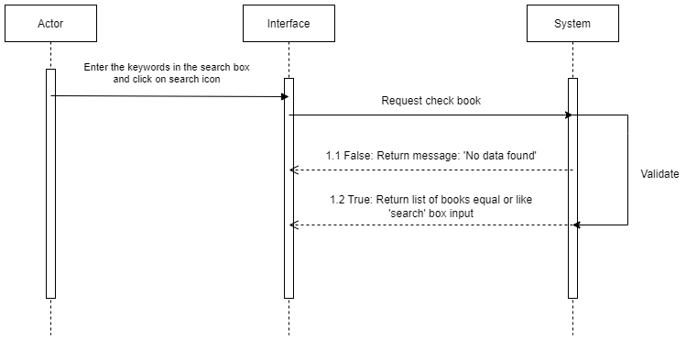

FC02. ACTIVITY FLOW- SEARCH BOOK

##### Flow of Events

#### Basic Flow

| Step | Description |
| --- | --- |
| 1. | Actor enters the keywords in the ‘Search’ Box. Actor clicks on the ‘Search’ icon |
| 2. | Actor clicks on the ‘Search’ icon |
| 3. | LiMS checks the database then displays a search results screen with the following fields and data – there will be a results row for each book whose information matches all or any of the keywords entered in Step 1. |

#### Alternative Flow - <No Data Found>

**Continued from step #3 in the Basic Flow:**

| Step | Description |
| --- | --- |
| 3.1 | LiMS checks the database. If there aren't any books meet the search criteria from keywords entered by actor, LiMS displays informational ‘No Data Found’ message |
| 3.2 | Continue at Step 1 in the Basic Flow |

#### Alternative Flow - <Press Enter to search>

**Continued from step #2**

|  |  |
| --- | --- |
| Step | Description |
| 2.1 | Actor press [Enter] key on keyboard |
| 2.2 | Continue at Step 3 in the Basic Flow |

#### Alternative Flow - <Not Enter the keywords>

|  |  |
| --- | --- |
| Step | Description |
| 1.1 | Actor does not enter any keywords on the ‘Search’ Box |
| 1.2 | Actor clicks on the ‘Search’ icon |
| 1.3 | LiMS popup a warning message “!!! Please fill out this field” |
| 1.4 | Continue at Step 1 in the Basic Flow |

#### Exceptional Flow - <No internet connection>

|  |  |
| --- | --- |
| Step | Description |
|  | Unplug the wifi routine or internet cable wire from the computer |
|  | The screen display informational message EMGS3 |

##### Mock-up Screen

|  |  |
| --- | --- |
| SB1.1. Enter KeyWords |  |
| SB1.2. Display Search Results |  |
| SB.1.1.1. Not Enter Keywords |  |
| SB 1.1.2. Lost Connection |  |
| SB 1.2.1. No Data Found |  |

##### Screen Description

SB- Header

| REF | Field Name | Control Type | Data Type | Default Value | Mandatory | Editable | Description |
| --- | --- | --- | --- | --- | --- | --- | --- |
| 1 | About Us | Hyperlink | Text | N/A | N/A | N/A | Information about LiMS |
| 2 | History | Hyperlink | Text | N/A | N/A | N/A | Click on History, LiMS will come to the list of books which the actor borrowed before. |
| 3 | Notification | Hyperlink | Text | N/A | N/A | N/A | The Notice for actor when any event happened for Student/Teacher |
| 4 | Account | Text Field | Text | N/A | N/A | N/A | Name & information of user account |
| 5 | Keyword Search field | Text box | Text | Blank | Y | Y | Type name of book that need to find |
| 6 | Search icon | Button | N/A | N/A | N/A | N/A | Search icon is disabled until user inputs value on keyword search field |
| 7 | Logo | Button | Image | N/A | N/A | N/A | After click to Logo => Back to LiMS Homepage |
| 8 | Topic | Label | Text | N/A | N/A | N/A | When actor clicks on it, LiMS will display Topic field in table Topic in database |
| 9 | Education Program | Label | Text | N/A | N/A | N/A | When actor clicks on it, LiMS will display Education Program field in table Education Program in database |
| 10 | Digital | Label | Text | N/A | N/A | N/A | When actor clicks on it, LiMS will display Digital field in table Digital in database |
| 11 | Analysis | Label | Text | N/A | N/A | N/A | When actor clicks on it, LiMS will display Analysis field in table Analysis in database |
| 12 | Get Help | Label | Text | N/A | N/A | N/A | When actor clicks on it, LiMS will display Screen ‘Get Help’ |

SB 1.1. Enter KeyWords

| REF | Field Name | Control Type | Data Type | Default Value | Mandatory | Editable | Description |
| --- | --- | --- | --- | --- | --- | --- | --- |
| 1 | View Detail | HyperLink | N/A | N/A | N/A | N/A | When actor clicks on author, it will be referred to the screen “View Book Information” |
| 2 | Title Book | Header | Text | N/A | N/A | N/A | N/A |
| 3 | Cover Box | Image | N/A | N/A | N/A | N/A | N/A |

SB1.2. Display Search Results

| REF | Field Name | Control Type | Data Type | Default Value | Mandatory | Editable | Description |
| --- | --- | --- | --- | --- | --- | --- | --- |
| 1 | Page 1 | Text | Text | N/A | N/A | N | Current page number of search list |
| 2 | 50 results | Text | Text | N/A | N/A | N/A | Total results that match with any word of keywork |
| 3 | Show only | Single selection Dropdown | N/A | N/A | N/A | N/A | Click on this and two options will appear: Library and Online. |
| 4 | Catalog | Single Selection Dropdown | N/A | N/A | N/A | N/A | Click on this and multiple options will appear, these options will be taken from the Catalog row in the Book table. |
| 5 | Author | Single selection Dropdown | N/A | N/A | N/A | N/A | Click on this and multiple options will appear, these options will be taken from the Author row in the Book table. |
| 6 | Year  of publication | Single selection Dropdown | N/A | N/A | N/A | N/A | Click on this and multiple options will appear, these options will be taken from the Year of publication row in the Book table. |
| 7 | Language | Single selection Dropdown | N/A | N/A | N/A | N/A | Click on this and multiple options will appear, these options will be taken from the language row in the Book table. |
| 8 | Sort by (Active Filter) | Label | Text | N/A | N/A | N/A | N/A |
| 9 | Book Title | Hyperlink | N/A | N/A | N/A | N/A | When actor clicks on book title, LiMS will refer to screen ‘View Book Information’ |
| 10 | Author | Hyperlink | N/A | N/A | N/A | N/A | When actor clicks on author, LiMS will refer to screen ‘View author’s detail’ |
| 11 | Publish date | Label | Text | N/A | N/A | N/A | Showing the publish date of the book. |
| 12 | Publish date Field | Text Field | Date | N/A | N/A | N/A | Date format MM DD, YY. |
| 13 |  | Icon | N/A | N/A | N/A | N/A | Represent for the rating of each book and base on five stars review |
| 14 | Total review | Text | Text | N/A | N/A | N/A | Count total feedback from readers |
| 15 | 1,2,3 | Text | Text | N/A | N/A | N/A | Ordinal number of books being displayed |
| 16 | > | Icon | N/A | N/A | N/A | N/A | Actor clicks on this icon to refer to the next result screen of search list |
| 17 | Menu bar | Button | N/A | N/A | N/A | N/A | Actor can change the screen displaying searched results based on the number on the button he clicks on. Example: click on button ‘7’ to refer to 7th list search result screen |

SB 1.1.1. Not Enter Keywords

| REF | Field Name | Control Type | Data Type | Default Value | Mandatory | Editable | Description |
| --- | --- | --- | --- | --- | --- | --- | --- |
| Similar to screen SB1.2. Display search results based on Keywords Screen and including | | | | | | | |
| 1 | Reminder text | Text field | Text | N/A | N/A | N/A | When an actor leaves ‘Search’ Box blank and clicks the search icon, this text will be displayed “!!! Please fill out this field” to remind the actor to fill in keyword to ‘Search’ box |

SB 1.1.2. Lost Connection

| REF | Field Name | Control Type | Data Type | Default Value | Mandatory | Editable | Description |
| --- | --- | --- | --- | --- | --- | --- | --- |
| Similar to screen SB1.1. Enter KeyWords Screen and including | | | | | | | |
| 1 | Connection Lost Message | Text field | Text | N/A | N/A | N/A | After actor click on search icon, the Connection Lost notification will be displayed |
| 2 |  | Button | Image | N/A | N/A | N/A | Actor can click on this button to close Connection Lost Message Website will return to the homepage |
| 3 | OK | Button | N/A | N/A | N/A | N/A | Actor can activate this button by 2 ways, click on this button by mouse or press [Enter] on Keyboard to close Connection Lost Message, Website will return the homepage |

SB 1.2.1. No Data Found Screen

| REF | Field Name | Control Type | Data Type | Default Value | Mandatory | Editable | Description |
| --- | --- | --- | --- | --- | --- | --- | --- |
| 1 | Page 1 | Text | Text | N/A | N/A | N/A | Current page number of search list |
| 2 | 0 result | Text | Text | N/A | N/A | N/A | Total results that match with any word of keywork |
| 3 | Menu bar | Button | N/A | N/A | N/A | N/A | Actor can change the screen displaying searched results based on the number on the button he clicks on. Example: click on button ‘7’ to refer to 7th list search result screen |
| 4 | No Data Found Message | Text Field | Text | N/A | N/A | N/A | Display ‘No Data Found’ Message |
| 5 | Ask a librarian | Hyperlink | Text | N/A | N/A | N/A | Link to chat with librarian |
| 6 | Pham Minh Hoang | Text | Text | N/A | N/A | N | Auto filled with keywords on ‘Search’ box |

##### Business Rules

|  |  |
| --- | --- |
| Business Rule ID | Business Rule Description |
| BRL-02-01 | **Search Box Rules:**  The ‘Search’ Box can not be blank when using search function |
| BRL-02-02 | **Search Results Displaying Rules:**  The results will be presented from top to bottom accordingly: Keywords match 100%, then match any word from the keywords |
| BRL-02-03 | **Connection Lost Notification Rules:**  In case of Connection-Lost occurrence, there will be a displayed message EMGS3 |
| BRL-02-04 | **‘No Data Found’ Message Rules:**  Display a message:  “No Data Found There are no results matching your search:[keywords]  Need help? Please  You may also wish to try your search with different keywords”  [keywords] = keywords in the ‘Search’ Box |

## UC03: <View Book Information>

##### Overview

|  |  |
| --- | --- |
| ID and Name | UC03 - View Book Information |
| Description | This use case allows the user to view the detailed information related of each book |
| Actor | All authenticated actors of this system, including Students. Teachers, Admins, Librarians. |
| Trigger | The user chooses to view detailed information in the list from the books display. |
| Pre-condition | User who has been granted with the corresponding permission.  Books for which actor want to view exist in the LiMS and must be displayed on the screen. |
| Post-condition | All information related to this book is displayed successfully. |

##### Activity Flow

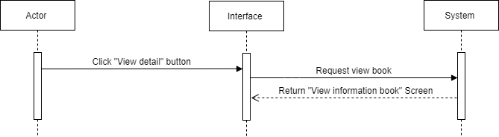

FC03. ACTIVITY FLOW-VIEW BOOK INFORMATION

##### Flow of Events

#### Basic Flow

| Step | Description |
| --- | --- |
| 1 | Actor clicks on the “View detail” Button of each book in the “Homepage” screen. |
| 2 | After actor’s clicking, the system will query in the database and then display a record of the book's information on the "View Book Information" screen with the following fields and data: book title, author name, publication date, preview of the table of contents, number of reviews and books borrowed, summary information and editions. |

#### Alternative Flow - Stop viewing information.

**Continued from step #2 in the Basic Flow:**

| Step | Description |
| --- | --- |
| 1 | Actor don’t want to view this book so click on the  icon in the navigation bar. |
| 2 | The system returns to the “Homepage” screen. |
| 3 | Actor can choose another book and the continue the #Step 1. |

#### Exceptional Flow - <Session Timeout>

**Continued from step #2 in the Basic Flow:**

|  |  |
| --- | --- |
| Step | Description |
| 1 | Actor doesn’t interact with “View Book Information” screen for more than 30 minutes |
| 2 | The message will appear automatically on EMGS6 and the actor must login again. |

#### Exceptional Flow - <No Internet>

**Continued from step #1, #2 in the Basic Flow:**

|  |  |
| --- | --- |
| Step | Description |
| 1 | Unplug the wifi routine or internet cable wire from the computer. |
| 2 | Screen display informational message EMGS3. |

##### Mock-up Screen

|  |  |
| --- | --- |
| VB1.1.Homepage |  |
| VB1.2. View Book Information |  |
| VB1.3. Connection Lost |  |

##### Screen Description

VB1.1.Homepage

| REF | Field Name | Control Type | Data Type | Default Value | Mandatory | Editable | Description |
| --- | --- | --- | --- | --- | --- | --- | --- |
| Similar to screen “SB1.1.1. Enter KeyWords Screen” | | | | | | | |

VB1.2. View Book Information

| REF | Field Name | Control Type | Data Type | Default Value | Mandatory | Editable | Description |
| --- | --- | --- | --- | --- | --- | --- | --- |
| Similar to screen “BB1.1. View Book Information” | | | | | | | |

VB1.3.3. Lost Connection

| REF | Field Name | Control Type | Data Type | Default Value | Mandatory | Editable | Description |
| --- | --- | --- | --- | --- | --- | --- | --- |
| 1 | Connection Lost Message | Text field | Text | N/A | N/A | N/A | After actor click on search icon, the Connection Lost notification will be displayed |
| 2 |  | Button | Image | N/A | N/A | N/A | Actor can click on this button to close Connection Lost Message Website will return to the homepage |
| 3 | OK | Button | N/A | N/A | N/A | N/A | Actor can activate this button by 2 ways, click on this button by mouse or press [Enter] on Keyboard to close Connection Lost Message, Website will return the homepage |

##### Business Rules

|  |  |
| --- | --- |
| Business Rule ID | Business Rule Description |
| BRL-03-01 | **Connection Lost Notification Rules:**  In case of Connection-Lost occurrence, there will be a displayed pop-up message EMGS3 |
| BRL-03-02 | **Screen Displaying Rules:**  The system will load a screen “View Book Information”: Display all the information that is being released in that book. After clicking the “View detail” button, all the detailed booking screens including name of book, author, total number of stars and borrowed, editions, publish date, description of this book.  Time out for this screen is 30 mins, after that time, the screen will reload and back to the screen “Login”, the actor has to input your account and password to login. After successfully login, the actor can continue step 1 in basic flow. |

## UC04: <View Author Information >

##### Overview

|  |  |
| --- | --- |
| ID and Name | UC04 - View Author Information |
| Description | This use case allows the user to view the detailed information related to the author. |
| Actor | All authenticated actors of this system, including Students. Teachers, Admins, Librarians. |
| Trigger | The user chooses to see detailed information about the book's author displayed on the screen |
| Pre-condition | The author of the book that the actor wants to see exists in LiMS by hyperlink and must be displayed on the screen. |
| Post-condition | All information related to this author is displayed successfully. |

##### Activity Flow

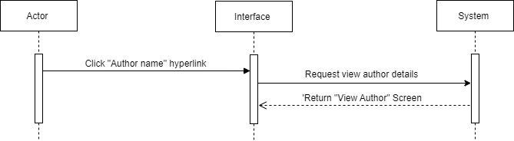

FC04. ACTIVITY FLOW- View Author Information

##### Flow of Events

#### Basic Flow

| Step | Description |
| --- | --- |
| 1 | Actor could click on the author name hyperlink in the screen “View Book Information” to view the author's information. |
| 2 | After clicking on the hyperlink, LiMS navigates to the “View author’s details”. All information about the author is shown on the screen, including the author's name, date of birth, biography and list of books written. |

#### Alternative Flow - Stop viewing information.

**Continued from step #2 in the Basic Flow:**

| Step | Description |
| --- | --- |
| 1 | Actor don’t want to view this book so click on the  icon in the navigation bar. |
| 2 | The system returns to the “View Book Information” screen. |

#### Alternative Flow - View author from “Search" screen.

**Continued from step #6 in the Basic Flow:**

|  |  |
| --- | --- |
| Step | Description |
| 1 | Actor clicks on the author's name hyperlink in the “Search” screen. |
| 2 | Continue step 2 in basic flow. |

#### Exceptional Flow - <Session Timeout>

**Continued from step #2 in the Basic Flow:**

|  |  |
| --- | --- |
| Step | Description |
| 1 | Actor doesn’t interact with “View Book Information” screen for more than 30 minutes |
| 2 | The message will appear automatically on EMGS6 and the actor must login again. |

#### Exceptional Flow - <No Internet>

**Continued from step #1, #2 in the Basic Flow:**

|  |  |
| --- | --- |
| Step | Description |
| 1 | Unplug the wifi routine or internet cable wire from the computer. |
| 2 | Screen display informational message EMGS3. |

##### Mock-up Screen

|  |  |
| --- | --- |
| VA1.1 View book information |  |
| VA1.2. View author’s details |  |

##### Screen Description

##### Business Rules

|  |  |
| --- | --- |
| Business Rule ID | Business Rule Description |
| BRL-03-01 | **Connection Lost Notification Rules:**  In case of Connection-Lost occurrence, there will be a displayed pop-up message EMGS3 |
| BRL-03-02 | **Screen Displaying Rules:**  The system will load a screen “View Author Information”: Display all the author’s information that is being released in that book. After clicking the “Author name” hyperlink, All information about the author is shown on the screen, including the author's name, date of birth, biography and list of books written.  Time out for this screen is 30 mins, after that time, the screen will reload and back to the screen “Login”, the actor has to input your account and password to login. After successfully login, the actor can continue step 1 in basic flow. |
| BRL-03-03 | **Author’s Name Displaying Rules:**   * In case there is no author, leave "Unknown" * In case of multiple authors, list each author's name and separate them by ",":   *[Author's name 1]*, *[Author's name 2]*, *[Author's name 3]*.  Where each [Author's Name] field is a hyperlink |

## UC05: <View All Editions>

##### Overview

|  |  |
| --- | --- |
| ID and Name | UC05 - View All Editions |
| Description | This use case allows the user to view the detailed information related of each book |
| Actor | All authenticated actors of this system, including Students. Teachers, Admins, Librarians. |
| Trigger | The user chooses to view all editions of this book in the tab bar. |
| Pre-condition | The book that the actor wants to see exist in LiMS and must be displayed on the screen. |
| Post-condition | All information related to this book is displayed successfully. |

##### Activity Flow

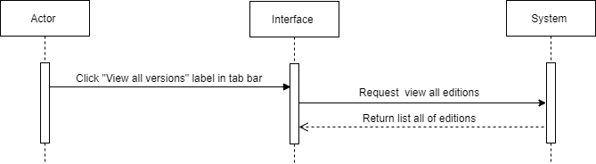

FC05. ACTIVITY FLOW- View all editions of book

##### Flow of Events

#### Basic Flow

| Step | Description |
| --- | --- |
| 1 | Actor could click on the “View all editions” label in the tab bar to see all the editions of this book. |
| 2 | The editions of the book will be displayed in the tab bar. |

#### Alternative Flow - Stop viewing information.

**Continued from step #2 in the Basic Flow:**

| Step | Description |
| --- | --- |
| 1 | Actor don’t want to view this book so click on the  icon in the navigation bar. |
| 2 | The system returns to the “Homepage” screen. |
| 3 | Actor can choose another book and the continue the #Step 1. |

#### Alternative Flow - Show data in tab bar.

**Continued from step #6 in the Basic Flow:**

|  |  |
| --- | --- |
| Step | Description |
| 1 | If actor clicks on the “Details” label in the tab bar, LiMS displays the data of the “details” field in the tab bar. |

#### Exceptional Flow - <Session Timeout>

**Continued from step #2 in the Basic Flow:**

|  |  |
| --- | --- |
| Step | Description |
| 1 | Actor doesn’t interact with “View Book Information” screen for more than 30 minutes |
| 2 | The message will appear automatically on EMGS6 and the actor must login again. |

#### Exceptional Flow - <No Internet>

**Continued from step #1, #2 in the Basic Flow:**

|  |  |
| --- | --- |
| Step | Description |
| 1 | Unplug the wifi routine or internet cable wire from the computer. |
| 2 | Screen display informational message EMGS3. |

##### Mock-up Screen

|  |  |
| --- | --- |
| VE1.1. View Book Information |  |
| VE1.2.View Book Information - Views all editions |  |

##### Screen Description

VE1.1. View Book Information

| REF | Field Name | Control Type | Data Type | Default Value | Mandatory | Editable | Description |
| --- | --- | --- | --- | --- | --- | --- | --- |
| Similar to screen “BB1.1. View Book Information” | | | | | | | |

VE1.2.View Book Information - Views all editions

| REF | Field Name | Control Type | Data Type | Default Value | Mandatory | Editable | Description |
| --- | --- | --- | --- | --- | --- | --- | --- |
| Similar to screen “BB1.2.View Book Information - Views all editions” | | | | | | | |

##### Business Rules

|  |  |
| --- | --- |
| Business Rule ID | Business Rule Description |
| BRL-03-01 | **Connection Lost Notification Rules:**  In case of Connection-Lost occurrence, there will be a displayed message EMGS3 |
| BRL-03-02 | **Screen Displaying Rules:**  The system will load a screen “View Author Information”: Display all the author’s information that is being released in that book. After clicking the “Author name” hyperlink, All information about the author is shown on the screen, including the author's name, date of birth, biography and list of books written.  Time out for this screen is 30 mins, after that time, the screen will reload and back to the screen “Login”, the actor has to input your account and password to login. After successfully login, the actor can continue step 1 in basic flow. |
| BRL-03-01 | **Not Exists Any Editions Rules:**  In the absence of any editions, the screen will display a message EMGS7 in the tab bar. |

## UC06: <Preview>

##### Overview

|  |  |
| --- | --- |
| ID and Name | UC06 - Preview Book |
| Description | This use case allows the user to view the book's table of contents. |
| Actor | All authenticated actors of this system, including Students. Teachers, Admins, Librarians. |
| Trigger | The user chooses to view detailed information in the list from the books display. |
| Pre-condition | User who has been granted with the corresponding permission.  Books for which actor want to view exist in the LiMS and must be displayed on the screen. |
| Post-condition | All information related to this book is displayed successfully. |

##### Activity Flow

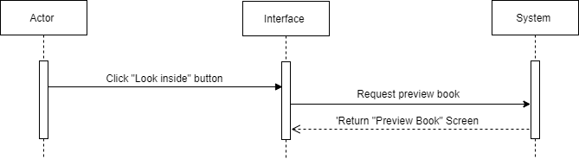

FC06. ACTIVITY FLOW- View Book Information

##### Flow of Events

#### Basic Flow

| Step | Description |
| --- | --- |
| 1 | Actor could click on the “Look inside” button to preview the book pages in the “View Book Information” screen. |
| 2 | The preview pop-up is shown and the actor can scroll to see. |

#### Alternative Flow - Stop viewing information.

**Continued from step #2 in the Basic Flow:**

| Step | Description |
| --- | --- |
| 1 | Actor don’t want to view this book so click on the  icon in the navigation bar. |
| 2 | The system returns to the “Homepage” screen. |
| 3 | Actor can choose another book and the continue the #Step 1. |

#### Alternative Flow - Stop previewing the book pages.

**Continued from step #4 in the Basic Flow:**

|  |  |
| --- | --- |
| Step | Description |
| 1 | If actor clicks the button “x” on the left corner of the pop-up.  LiMS displays the ”View Book Information”. |

#### Exceptional Flow - <Session Timeout>

**Continued from step #2 in the Basic Flow:**

|  |  |
| --- | --- |
| Step | Description |
| 1 | Actor doesn’t interact with “View Book Information” screen for more than 30 minutes |
| 2 | The message will appear automatically on EMGS6 and the actor must login again. |

#### Exceptional Flow - <No Internet>

**Continued from step #1, #2 in the Basic Flow:**

|  |  |
| --- | --- |
| Step | Description |
| 1 | Unplug the wifi routine or internet cable wire from the computer. |
| 2 | Screen display informational message EMGS3. |

##### Mock-up Screen

|  |  |
| --- | --- |
| PB1.4 View Book Information |  |
| PB1.4.1 Preview Book. |  |
| PB1.4.2. Preview Book 2. |  |
| PB1.4.3. Preview Book 3. |  |

##### Screen Description

PB1.4. View Book Information

| REF | Field Name | Control Type | Data Type | Default Value | Mandatory | Editable | Description |
| --- | --- | --- | --- | --- | --- | --- | --- |
| Similar to screen “BB1.1. View Book Information” | | | | | | | |

##### 

PB1.4.1 Preview Book.

PB1.4.2. Preview Book 2.

PB1.4.3. Preview Book 3.

| REF | Field Name | Control Type | Data Type | Default Value | Mandatory | Editable | Description |
| --- | --- | --- | --- | --- | --- | --- | --- |
| 1 | Image of Book | Image | N/A | N/A | N/A | N/A | Showing picture of table content book. |
| 2 | Annotation | Text | Text | N/A | N/A | N/A | This explanation for an actor about the book’s sample is : “This is a sample. The number of pages displayed is limited” |
| 3 |  | Button | N/A | N/A | N/A | N/A | Actor clicks to close the pop-up and the screen “View Book Information” is displayed. |

##### Business Rules

|  |  |
| --- | --- |
| Business Rule ID | Business Rule Description |
| BRL-03-01 | **Connection Lost Notification Rules:**  In case of Connection-Lost occurrence, there will be a displayed message EMGS3 |
| BRL-03-02 | **Screen Displaying Rules:**  The system will load a screen “Preview Book '': Display all the images related to this book ( cover book, table of contents, appendix).  Actor can scroll to view the book.  Time out for this screen is 30 mins, after that time, the screen will reload and back to the screen “Login”, the actor has to input your account and password to login. After successfully login, the actor can continue step 1 in basic flow. |
| BRL-03-01 | **No Preview Information Rules:**  In the absence of preview information, the screen will display pop-up with an error message there will be a displayed message EMGS7 |

## UC07: <Request purchase book>

##### Overview

|  |  |
| --- | --- |
| ID and Name | UC07 - Request purchase book |
| Description | Allow student and teacher request purchase any books in LiMS by their accounts |
| Actor | Student/Teacher |
| Trigger | After login to a student or teacher, click on the “Borrow” button on any books on the “View Book Information” screen of any books. |
| Pre-condition | Books which student or teacher request to purchase are available,  (All of the books are not available in library) |
| Post-condition | - Send email request purchase successfully and change status of this book in database  - Send email, reject the request and not change the status of this book in the database.  - The number of books purchased increased.  - Message SMSG3 is displayed.  - Save in the database. |

##### Activity Flow

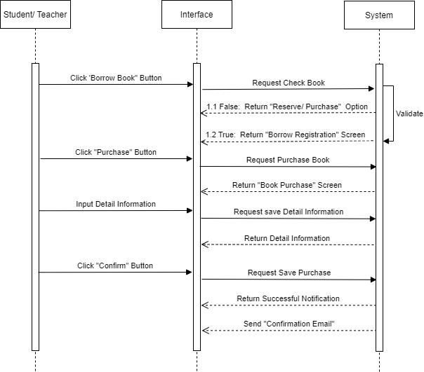

PROCESS-01: REQUEST PURCHASE BOOK

##### Flow of Events

#### Basic Flow

| Step | Description |
| --- | --- |
| 1 | Actor clicks on the “Borrow Book” Button in the “View Book Information” screen of any books. |
| 2 | System checks status of book in database, in unavailable bookcase, “Reserve/ Purchase” Option appears. |
| 3 | Actor clicks on the “Purchase” Button on “Reserve/ Purchase” Option. |
| 4 | “Purchase Request Book” screen including date, name of book, author and editions, publish date will be displayed. |
| 5 | Input Detail Information in “Purchase Request Book” screen. |
| 6 | Click on “Confirm” Button. |
| 7 | LiMS saves the reservation in the database and returns Successful Notification with message SMSG3. |
| 8 | LiMS sends Confirmation Email ET3 to confirm complete purchase. |

#### Alternative Flow - Unavailable book - Request reserve case

**Continued from step #2 in the Basic Flow:**

| Step | Description |
| --- | --- |
| 1 | When the “Reserve/ Purchase” Option appears, the actor clicks on the “Reserve” Button. |
| 2 | “Reserve Book” screen is displayed. |

#### Alternative Flow - Unavailable book - Click “X” to cancel

**Continued from step #2 in the Basic Flow:**

| Step | Description |
| --- | --- |
| 1 | The actor clicks on “X” Button to cancel the Option, LiMS displays the previous screen “View Book Information”. |

#### Exceptional Flow - <No Internet>

**Continued from all steps in the Basic Flow:**

|  |  |
| --- | --- |
| Step | Description |
| 1 | Unplug the wifi routine or internet cable wire from the computer |
| 2 | The screen displays an informational message: ‘Connection Lost. Please check your networking”’ |

#### Exceptional Flow - <Session Timeout>

**Continued from all steps in the Basic Flow:**

|  |  |
| --- | --- |
| Step | Description |
| 1 | Actor doesn’t interact with the “Purchase Book” screen for more than 15 minutes. |
| 2 | The message EMGS6 will appear automatically and LiMS returns to the “View Book Information” screen. |

#### Exceptional Flow - <Server overload>

**Continued from all step #6 in the Basic Flow:**

|  |  |
| --- | --- |
| Step | Description |
| 1 | Too many people attempt to visit LiMS at the same time causing the server to become overloaded. |
| 2 | LiMS returns Error screen with massage [EMGS8](https://docs.google.com/document/d/1C0bqQfC6GhnxFzApvPjgu0FsxscbbXMc/edit#heading=h.k885n42szwkg) |

##### Mock-up Screen

|  |  |
| --- | --- |
| PB1.1. View Book Information - Click button “Borrow book” |  |
| PB 1.2 View Book Information - Reserve/ Purchase Option |  |
| PB 2.1 Purchase Book - Check the “Purchase the book” |  |
| PB 2.2 Purchase Book - Input Book Information Detail |  |
| PB 2.3 Purchase Book - Successful Notification |  |
| PB 3.1 Confirmation Email |  |

##### Screen Description

PB1.1. View Book Information - Click button “Borrow book”

| REF | Field Name | Control Type | Data Type | Default Value | Mandatory | Editable | Description |
| --- | --- | --- | --- | --- | --- | --- | --- |
| Similar to screen “BB1.1. View Book Information” | | | | | | | |

PB 1.2 View Book Information - Reserve/ Purchase Option

| REF | Field Name | Control Type | Data Type | Default Value | Mandatory | Editable | Description |
| --- | --- | --- | --- | --- | --- | --- | --- |
| * Similar to screen “BB 2.2 Book borrow - Reserve/ Purchase Option” | | | | | | | |

PB 2.1 Purchase Book - Check the “Purchase the book”

| REF | Field Name | Control Type | Data Type | Default Value | Mandatory | Editable | Description |
| --- | --- | --- | --- | --- | --- | --- | --- |
| 1 | Book Name | Hyperlink | Text | N/A | N/A | N/A | Name of the book that actor wants to reserve.  It will be linked to “View Book Information” screen of LiMS. |
| 2 | Author Name | Hyperlink | Text | N/A | N/A | N/A | When actor clicks on author, it will be referred to the screen “View author’s detail” |
| 3 | Book Information | Text Area | Text | N/A | N/A | N/A | Show some information about the book: Edition; Material Type; Format; Literary; Publisher; Publish date. |
| 4 | Book Cover | Image | Image | N/A | N/A | N/A | N/A |
| 5 |  | Button | Image | N/A | N/A | N/AA | Actor can click on this button to review the book. There are a total of 5 buttons corresponding to: 1 star is the worst and 5 stars is the best.  After clicking on the button, the button will show number of stars present for average stars of the total number of reviews. |
| 6 | Confirm purchase for | Text Field | Text | N/A | N/A | N/A | N/A |
| 7 |  | Button | Image | N/A | N/A | N/A | After actor clicks on check box to agree with the purchase, “Confirm” button will be enabled to click on to purchase the book. |

PB 2.2 Purchase Book - Input Book Information Detail

| REF | Field Name | Control Type | Data Type | Default Value | Mandatory | Editable | Description |
| --- | --- | --- | --- | --- | --- | --- | --- |
| Similar to screen “PB 2.1 Purchase Book - Check the “Purchase the book” | | | | | | | |

PB 2.3 Purchase Book - Successful Notification

| REF | Field Name | Control Type | Data Type | Default Value | Mandatory | Editable | Description |
| --- | --- | --- | --- | --- | --- | --- | --- |
|  | | | | | | | |
| 1 | Success Message | Text | Text | N/A | N/A | N/A | After the actor clicks on the “Confirm” button, the success notification will be displayed with SMSG2 and the “View Book Information” screen will be disable. |
| 2 |  | Button | Image | N/A | N/A | N/A | Actor can click on this button to close “Success Notification”, Website will return the previous page “View book Information” |
| 3 | OK | Button | Image | N/A | N/A | N/A | Actor can activate this button by 2 ways, click on this button by mouse or press [Enter] on Keyboard to close “Success Notification” , Website will return the previous page “View book Information” |

RB 3.1 Confirmation Email

| REF | Field Name | Control Type | Data Type | Default Value | Mandatory | Editable | Description |
| --- | --- | --- | --- | --- | --- | --- | --- |
| 1 | Email Title | Text Field | Text | N/A | N/A | N/A | * “Your borrowing request for XXX is successful!” |
| 2 | Email Content | Text Area | Text | N/A | N/A | N/A | Follow email form ET2  Email contains hyperlink fields that are customizable for each request. |
| 3 | Student/  Teacher’s Name | Text Field | Text | Name of the student/ teacher who sent the request | N/A | N/A | Name of the student/ teacher who sent the borrowing request is in the actor's profile that is saved in the database and will be automatically filled in this field. |
| 4 | Book Name | Hyperlink | Text | The name of book that student/ teacher sent request for | N/A | N/A | The name of the book that the actor wants to borrow is saved in database and will be automatically filled by the system in this field.  This field will be linked to [View Book Information] screen of LiMS. |
| 4 | Book Detail | Hyperlink | Text | N/A | N/A | N/A | It will be hyperlink into “here” text and will be linked to “View Book Information” screen of LiMS. |

##### Business Rules

|  |  |
| --- | --- |
| Business Rule ID | Business Rule Description |
| BRL-07-01 | **Screen Displaying Rule:**  The system will load a screen “View Book Information”: Display all the information that is being released in that book.  After clicking the “Purchase” button, all the detailed purchase screens including Book name, ID and Book Information Detail.  Time out for this screen is 15 mins, after that time, the screen will reload and back to screen “View Book Information” |
| BRL-07-02 | **Purchase Confirmation Rule:**  The actor must check the box “Reserve the box” to activate the “Confirm” button.Before that, this button is disable. When the “Confirm” button is enabled, the actor can click on to send the reservation.  After the actor clicks on the “Confirm” button. If the booking is completed:  v The System will display the successful notification SMSG3  v The System will send the email ET 3 to notify the successful request to purchase the book . |

## UC08: <Reserve Book>

##### Overview

|  |  |
| --- | --- |
| ID and Name | UC08 - Reserve Book |
| Description | This use case allows teacher and student to place a hold on the book that has been borrowed by others (unavailable in LiMS). |
| Actor | Teacher/ Student |
| Trigger | After logging in to LiMS, the student or teacher clicks on the “Borrow Book” button on the “View Book Information” screen of any books. |
| Pre-condition | Book which a student or teacher requests to reserve is unavailable.  (All of the books have been borrowed by others) |
| Post-condition | - Successful Notification with message SMSG2 is shown.  - Save reservations in the database.  - Send Confirmation Email ET2. |

##### Activity Flow

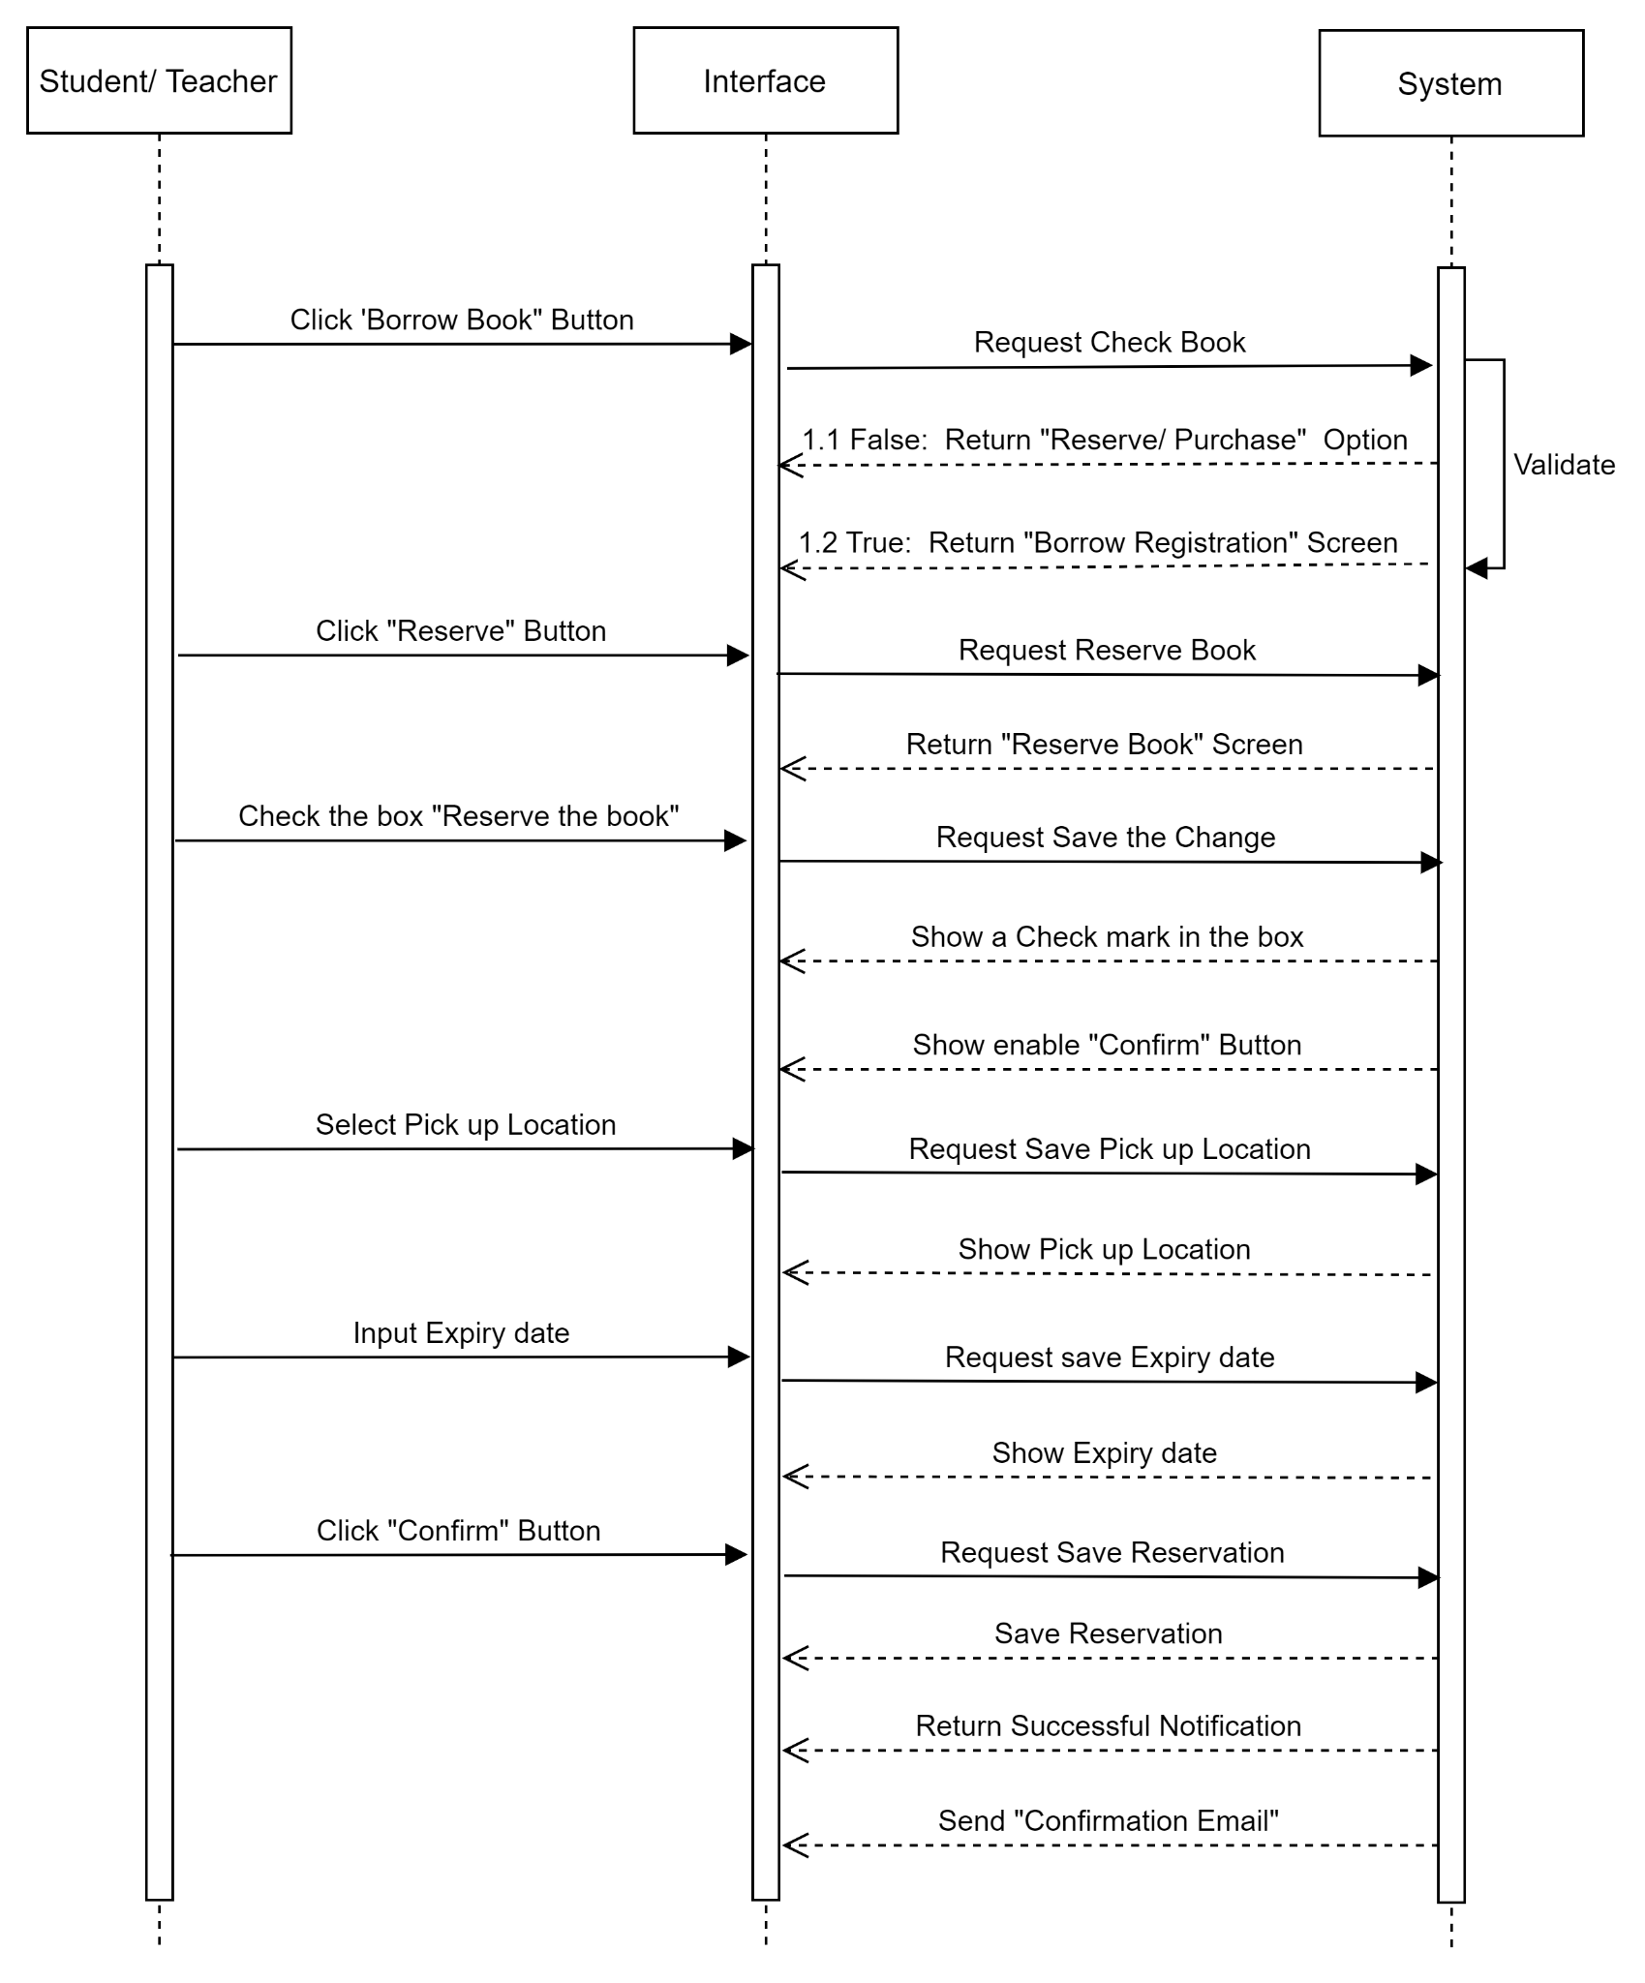

FC05. ACTIVITY FLOW- RESERVE BOOK

##### Flow of Events

#### Basic Flow

| Step | Description |
| --- | --- |
| 1 | Actor clicks on the “Borrow Book” Button in the “View Book Information” screen of any books. |
| 2 | System checks status of book in database, in unavailable bookcase, “Reserve/ Purchase” Option appears. |
| 3 | Actor clicks on the “Reserve” Button on the “Reserve/ Purchase” Option. |
| 4 | “Reserve Book” screen including date, name of book, author and editions, publish date will be displayed. |
| 5 | Actor checks the box “Reserve the book”,  the mark is shown in the checkbox. |
| 6 | Actor selects pick up location on Pick up Location Dropdown List, selected pickup location is shown in [Pick up Location Field]. |
| 7 | Input expiry date on [Expiry Date Field] next to “Reservation not needed after:” label, Inputted date is shown in the [Expiry Date Field]. |
| 8 | Click on “Confirm” Button to send the reservation. |
| 9 | LiMS saves the reservation in the database and returns Successful Notification with message SMSG2. |
| 10 | LiMS sends Confirmation Email ET2 to confirm complete reservation . |

#### Alternative Flow - Unavailable book - Request purchase case

**Continued from step #2 in the Basic Flow:**

| Step | Description |
| --- | --- |
| 1 | When “Reserve/ Purchase” Option is appear, actor clicks on “Purchase” Button. |
| 2 | “Purchase Book” screen is displayed. |

#### Alternative Flow - Available book - Request borrow case

**Continued from step #1 in the Basic Flow:**

| Step | Description |
| --- | --- |
| 1 | System checks status of book in database, in available book case, “Borrow Registration” screen will be displayed to request borrow book. |

#### Alternative Flow - Unavailable book - Click “X” to cancel

**Continued from step #2 in the Basic Flow:**

| Step | Description |
| --- | --- |
| 1 | The actor clicks on “X” Button to cancel the Option, LiMS display the previous screen “View Book Information”. |

#### Alternative Flow - Do not select Pick up Location

**Continued from step #5 in the Basic Flow:**

|  |  |
| --- | --- |
| Step | Description |
| 1 | Actor doesn’t select pick up location on Pick up Location Dropdown List, default pickup location is shown in [Pick up Location Field]. |
| 2 | Continue step #7 to step #10 in the Basic Flow. |

#### Alternative Flow - Do not input Expiry Date

**Continued from step #6 in the Basic Flow:**

|  |  |
| --- | --- |
| Step | Description |
| 1 | Actor doesn’t input expiry date on [Expiry Date Field] next to “Reservation not needed after:” label, LiMS know that this reservation has no expiry date. |
| 2 | Continue step #8 to step #10 in the Basic Flow. |

#### Alternative Flow - Do not input Expiry Date & Pick up Location

**Continued from step #5 in the Basic Flow:**

|  |  |
| --- | --- |
| Step | Description |
| 1 | Actor doesn’t select the pick up location on Pick up Location Dropdown List, default pickup location is shown in [Pick up Location Field]. |
| 2 | Actor doesn’t input expiry date on [Expiry Date Field] next to “Reservation not needed after:” label, LiMS knows that this reservation has no expiry date. |
| 3 | Continue step #8 to step #10 in the Basic Flow. |

#### Exceptional Flow - <No Internet>

**Continued from all steps in the Basic Flow:**

|  |  |
| --- | --- |
| Step | Description |
| 1 | Unplug the wifi routine or internet cable wire from the computer  (All cases of No internet connection <due to unplugging of the network cable, server failure…>) |
| 2 | EMGS3 is shown to notify for “No Internet” error. |

#### Exceptional Flow - <Session Timeout>

**Continued from all steps in the Basic Flow:**

|  |  |
| --- | --- |
| Step | Description |
| 1 | Actor doesn’t interact with the “Purchase Book” screen for more than 15 minutes. |
| 2 | The message EMGS6 will appear automatically and LiMS returns to the “View Book Information” screen. |

#### Exceptional Flow - <Server overload>

**Continued from all step #8 in the Basic Flow:**

|  |  |
| --- | --- |
| Step | Description |
| 1 | Too many people attempt to visit LiMS at the same time causing the server to become overloaded. |
| 2 | LiMS returns Error screen with massage [EMGS8](https://docs.google.com/document/d/1C0bqQfC6GhnxFzApvPjgu0FsxscbbXMc/edit#heading=h.k885n42szwkg) |

##### Mock-up Screen

|  |  |
| --- | --- |
| RB1.1. View Book Information - Click “Borrow book” button |  |
| RB 1.2 View Book Information - Reserve/ Purchase Option |  |
| RB 2.1 Reserve Book - Check the Box “Reserve the book” |  |
| RB 2.2 Reserve Book - Select Pick up location |  |
| RB 2.3 Reserve Book - Input Expiry Date |  |
| RB 2.4 Reserve Book - Successful Notification |  |
| RB 3.1 Confirmation Email |  |

##### Screen Description

RB1.1. View Book Information - Click button “Borrow book”

| REF | Field Name | Control Type | Data Type | Default Value | Mandatory | Editable | Description |
| --- | --- | --- | --- | --- | --- | --- | --- |
| Similar to screen “BB1.1. View Book Information” | | | | | | | |

##### 

RB 1.2 View Book Information - Reserve/ Purchase Option

| REF | Field Name | Control Type | Data Type | Default Value | Mandatory | Editable | Description |
| --- | --- | --- | --- | --- | --- | --- | --- |
| * Similar to screen “BB 2.2 Book borrow - Reserve/ Purchase Option” | | | | | | | |

##### 

RB 2.1 Reserve Book - Check the Box “Reserve the book”

| REF | Field Name | Control Type | Data Type | Default Value | Mandatory | Editable | Description |
| --- | --- | --- | --- | --- | --- | --- | --- |
| 1 | Book Name | Hyperlink | Text | N/A | N/A | N/A | Name of the book that actor clicked on to reserve.  It will be linked to “View Book Information” screen of LiMS. |
| 2 | Author Name | Hyperlink | Text | N/A | N/A | N/A | When actor clicks on “Author Name” field, it will be referred to the screen “View author’s detail” |
| 3 | Book Information | Text Area | Text | N/A | N/A | N/A | Show some information about the book: Edition; Material Type; Format; Literary; Publisher; Publish date. |
| 4 | Book Cover | Image | Image | N/A | N/A | N/A | N/A |
| 5 |  | Icon | N/A | N/A | N/A | N/A | Actor can click on this button to review the book. There are a total of 5 buttons corresponding to: 1 star is the worst and 5 stars is the best.  After clicking on the button, the button will show number of stars present for average stars of the total number of reviews. |
| 6 |  | CheckBox | N/A | N/A | Y | Y | When actor clicks on this check box to agree with the reservation, “Confirm” button will be enabled to click on. |
| 7 | Confirm reservation for | Text Field | Text | N/A | N/A | N/A | N/A |
| 8 | Teacher/ Student Name | Hyperlink | Text | N/A | N/A | N/A | Name of the student/ teacher who is logging in LiMS is in the actor's profile that is saved in the database and will be automatically filled in this field.  It will be linked to actor's profile screen of LiMS. |
| 9 | Reserve the book | Label | Text | N/A | N/A | N/A | Label of CheckBox |
| 10 | Pick up Location | Label | Text | N/A | N/A | N/A | Explanation for [Pickup Location Field] |
| 11 | Pickup Location Field | Dropdown List | Text | 1st floor of Library | N | Y | If actor don’t change this field, they must go to the default location to pick up the book. |
| 12 | Reservation not  needed after: | Label | Text | N/A | N/A | N/A | Explanation for [Expiry Date Field] |
| 13 | Expiry Date Field | Date Picker | Date | Null | N | Y | If the actor doesn’t input an expiry date in this field, system will know that this reservation has no expiry date.  If the actor input an expiry date in this field. This date must be equal or greater than the current day. The days from the current day will be enabled to select and the other will be disable. |
| 14 |  | Button | Image | N/A | N/A | N/A | After actor clicks on checkbox to agree with the reservation, “Confirm” button will be enabled to click on to reserve the book. |

RB 2.2 Reserve Book - Select Pick up location

| REF | Field Name | Control Type | Data Type | Default Value | Mandatory | Editable | Description |
| --- | --- | --- | --- | --- | --- | --- | --- |
| Similar to screen “RB 2.1 Reserve Book - Check the Box “Reserve the book” | | | | | | | |

RB 2.3 Reserve Book - Input Expiry Date

| REF | Field Name | Control Type | Data Type | Default Value | Mandatory | Editable | Description |
| --- | --- | --- | --- | --- | --- | --- | --- |
| Similar to screen “RB 2.1 Reserve Book - Check the Box “Reserve the book” | | | | | | | |

RB 2.4 Reserve Book - Successful Notification

| REF | Field Name | Control Type | Data Type | Default Value | Mandatory | Editable | Description |
| --- | --- | --- | --- | --- | --- | --- | --- |
|  | | | | | | | |
| 1 | Success Message | Text | Text | N/A | N/A | N/A | After the actor clicks on the “Confirm” button, the success notification will be displayed with SMSG2 and the “View Book Information” screen will be disable. |
| 2 |  | Button | Image | N/A | N/A | N/A | Actor can click on this button to close “Success Notification”, Website will return the previous page “View book Information” |
| 3 | OK | Button | Image | N/A | N/A | N/A | Actor can activate this button by 2 ways, click on this button by mouse or press [Enter] on Keyboard to close “Success Notification” , Website will return the previous page “View book Information” |

##### 

RB 3.1 Confirmation Email

| REF | Field Name | Control Type | Data Type | Default Value | Mandatory | Editable | Description |
| --- | --- | --- | --- | --- | --- | --- | --- |
| 1 | Email Title | Text Field | Text | N/A | N/A | N/A | “Your reservation for XXX is successful!” |
| 2 | Email Content | Text Area | Text | N/A | N/A | N/A | Follow email form ET2  Email contains hyperlink fields that are customizable for each request. |
| 3 | Student/  Teacher’s Name | Text Field | Text | Name of the student/ teacher who sent the request | N/A | N/A | Name of the student/ teacher who sent the reservation is in the actor's profile that is saved in the database and will be automatically filled in this field. |
| 4 | Book Name | Hyperlink | Text | The name of book that student/ teacher sent request for | N/A | N/A | The name of the book that the actor reserves is saved in database and will be automatically filled by the system in this field.  This field will be linked to [View Book Information] screen of LiMS. |
| 5 | Author | Hyperlink | Text | N/A | N/A | N/A | Author name of the book that the actor reserves is saved in a database and will be automatically filled by the system in this field.  This field will be linked to [View author’s detail] screen of LiMS. |
| 6 | Publish Date | Text Field | Date | N/A | N/A | N/A | Publish Date of the book that the actor reserves is saved in the database and will be automatically filled by the system in this field.  Date format MM/DD/YY |
| 7 | Pick up Location | Text Field | Text | N/A | N/A | N/A | Pick up Location that the actor selected in reserve request is saved in the database and will be automatically filled by the system in this field. |
| 8 | Expiry Date | Text Field | Date | N/A | N/A | N/A | Expiry Date of reservation that the actor inputted in reserve request is saved in the database and will be automatically filled by the system in this field.  Date format MM/DD/YY |
| 9 | Book Detail | Hyperlink | Text | N/A | N/A | N/A | It will be hyperlink into “here” text and will be linked to “View Book Information” screen of LiMS. |

##### 

##### Business Rules

|  |  |
| --- | --- |
| Business Rule ID | Business Rule Description |
| BRL-08-01 | **Screen Displaying Rule:**  The system will load a screen “View Book Information”: Display all the information that is being released in that book.  After clicking the “Reserve” button, all the detailed reservation screens including date, name of book, author and editions, publish date will be displayed.  Time out for this screen is 15 mins, after that time, the screen will reload and back to screen “View Book Information” |
| BRL-08-02 | **Reservation Confirmation Rule:**  The actor must check the box “Reserve the box” to activate “Confirm” button.Before that, this button is disable. When “Confirm” button is enabled, the actor can click on to send the reservation.  After the actor clicks on the button “Confirm” button. If the booking is completed:  v The System will display the successful notification SMSG2  v The System will send the email ET2 to notify the successful request for the book reservation. |
| BRL-08-03 | **Number of Request Rule:**  v Each actor can only reserve up to 5 books.  After the actor reserves 5 books, the “Reserve” button will be disable, so the actor can’t click on to reserve other books.  v Each request is default for reservation of 1 book. And the actor can’t reserve many times for the same book.  When the actor tries to send many reservations for the same book, the notification will appear “You have placed your hold for this book!” and the reservation won’t be accepted. |
| BRL-08-04 | **Complete Reservation Rule:**  After the actor sent the reservation successfully, when the book is available:  v System will check the number of books that the actor borrowed.  If the number of borrowed books is 5 books, send a notification to notify the actor “The book that you want to borrow is available now. But you need to return another book in order to borrow this book”.  If the number of borrowed books is less than 5 books, send the confirmation email ET1 for the successful borrowing request. |
| BRL-08-05 | **Expiry Date Rule:**  If the actor doesn’t input an expiry date in this field, system will know that this reservation has no expiry date.  In No Expiry date case, the system knows that the reservation won’t expire until the book is available to borrow.  If the actor input an expiry date in this field. This date must be equal or greater than the current day. The days from the current day will be enabled to select and the others will be disable.  In Expiry date case, when the reservation expires but the book is still unavailable:  v The reservation will be cancelled automatically.  v System will send a notification to notify the actor EMGS2 |
| BRL-08-06 | **Many People Reserve the Same Book:**  In the case that there are many people reserve the same book:  v Waiting list will be sorted by chronological order.  v When the book is available, it will be lent to the person who reserves it earliest. |

## UC09: <Approve/ Reject purchase book>

##### Overview

|  |  |
| --- | --- |
| ID and Name | UC6 -Approve/Reject Purchase Book |
| Description | This use case allows Librarian has right to accept or reject the request purchase of a Student/Teacher . |
| Actor | Libralian |
| Trigger | After logging in to LiMS, Libralian clicks on the “Your Approve” button on “Office” screen. |
| Pre-condition | Student/Teacher submit successfully purchase request form |
| Post-condition | - Message is displayed: “Approved.” |

##### Activity Flow

FC07. ACTIVITY FLOW- APPROVE REQUEST PURCHASE BOOK

##### Flow of Events

#### Basic Flow

| Step | Description |
| --- | --- |
| 1 | Actor clicks on “For Your Approve” Label in “Office” screen. |
| 2 | System open the List of Request for purchase by Student/Teacher submit successfully |
| 3 | Actor clicks on “View Detail” to view fully Request form |
| 4 | System open screen of “Purchase registration form” |
| 5 | Actor checks form and decides to “approve” then click on “Approve” button |
| 6 | System returns to “List of request for purchase” screen with the status of Request has changed “Approved” instead of “View Detail” also the system will sent email to requester |

#### Alternative Flow – Reject the “request for purchase book”

**Continued at step #4 in the Basic Flow:**

| Step | Description |
| --- | --- |
| 5.1 | Actor clicks on “Reject” Button |
| 5.2 | The system will pop-up the blank “Reason for reject”, Actor have to typing the |
| 5.3 | Actor has to typing the reason for reject request then click “OK” |
| 6.1 | System returns to “List of request for purchase” screen with the status “Rejected” |

#### Alternative Flow – Reject the “request for purchase book”

**Continued at step #4 in the Basic Flow:**

| Step | Description |
| --- | --- |
| 5.1 | Actor clicks on “Reject” Button |
| 5.2 | The system will pop-up the blank “Reason for reject”, Actor have to typing the |
| 5.3 | Actor has to typing the reason for reject the request then click “OK” |
| 6.1 | System returns to “List of request for purchase” screen with the status “Rejected” |

#### Alternative Flow – Approve once time for one book

**Continued from step #5 in the Basic Flow:**

| Step | Description |
| --- | --- |
| 5.1 | Actor clicks on “Approve” Button |
| 6.1 | System returns to “List of request for purchase” screen with the status “Approved” for all the request for book which just approved |

#### Exceptional Flow - <Session Timeout>

**Continued from step #2 in the Basic Flow:**

|  |  |
| --- | --- |
| Step | Description |
| 2.1 | Actor doesn’t interact with “List of request to purchase” screen for more than 15 minutes |
| 2.2 | The message will appear automatically on EMGS6 and the actor must login again. |

#### Exceptional Flow - <No Internet>

**Continued from step #1, #2 in the Basic Flow:**

|  |  |
| --- | --- |
| Step | Description |
| 1 | Unplug the wifi routine or internet cable wire from the computer. |
| 2 | Screen display informational message EMGS3. |

##### Mock-up Screen

|  |  |
| --- | --- |
| AP 1.1 Header “For your Approve” in Office Tab Bar |  |
| AP 1.2 Request to Purchase list |  |
| AP 1.3 View Detail of each Request |  |
| AP 1.4 Status changed after Approve |  |
| AP 1.5. Note reason for Reject |  |
| AP 1.6 Status after has changed after rejected |  |

##### Screen Description

AP 1.1 Header “For your Approve” in Office Tab Bar

| REF | Field Name | Control Type | Data Type | Default Value | Mandatory | Editable | Description |
| --- | --- | --- | --- | --- | --- | --- | --- |
| 1 | About Us | Hyperlink | Text | N/A | N/A | N/A | Information about LiMS |
| 2 | History | Hyperlink | Text | N/A | N/A | N/A | Click on History, LiMS will come to the list of books which the actor borrowed before. |
| 3 | Notification | Hyperlink | Text | N/A | N/A | N/A | The Notice for actor when any event happened for Student/Teacher |
| 4 | Account | Text Field | Text | N/A | N/A | N/A | Name & information of user account |
| 5 | Search book | Text box | Alpha | N/A | N | Y | Click to Search book and typing name of book that needed to find |
| 6 | Logo | Button | Image | N/A | N/A | N/A | After click to Logo => Back to LiMS Homepage |
| 7 | Office | Label | Text | N/A | N/A | N/A | *(Just have in Libralian account)*  When actor clicks on Office, LiMS will display the function that actor can view & use in which only libralian can |
| 7 | Topic | Label | Text | N/A | N/A | N/A | When actor clicks on it, LiMS will display Topic field in table Topic in database |
| 8 | Education Program | Label | Text | N/A | N/A | N/A | When actor clicks on it, LiMS will display Education Program field in table Education Program in database |
| 9 | Digital | Label | Text | N/A | N/A | N/A | When actor clicks on it, LiMS will display Digital field in table Digital in database |
| 10 | Analysis | Label | Text | N/A | N/A | N/A | When actor clicks on it, LiMS will display Analysis field in table Analysis in database |
| 11 | Get Help | Label | Text | N/A | N/A | N/A | When actor clicks on it, LiMS will display Screen ‘Get Help’ |

AP 1.2 Request to Purchase list

| REF | Field Name | Control Type | Data Type | Default Value | Mandatory | Editable | Description |
| --- | --- | --- | --- | --- | --- | --- | --- |
| 1 | For your Approve | Label | Text | N/A | N/A | N/A | After click, LiMS will display screen of Request to Purchase list for actor to approve |
| 2 | Name | Text Field | Text | N/A | N/A | N | These the name of student who sent the request |
| 3 | ID | Text Field | Number | N/A | N/A | N | The ID of student who sent the request |
| 4 | Request date | Label | Text | N/A | N/A | N | The Date that actor sent the request explain for the date submit successfully |
| 5 | Image of book | Image | N/A | N/A | N/A | N | Showing the picture of book request to purchase |
| 6 |  | icon | N/A | N/A | N/A | N/A | Number of notice that actor hasn’t click to view |
| 7 | *View Detail* | Hyperlink | Text | N/A | N/A | N/A | Open the screen to view the detail form of request |
| 8 | Approved | Text | Text | N/A | N/A | N/A | Status of request that actor has been approved |
| 9 | Reject | Text | Text | N/A | N/A | N/A | Status of request that actor has been rejected |
| 10 | Book ID | Label | Text | N/A | N/A | N/A | Explain for book ID |

AP 1.3 View Detail of each Request

| REF | Field Name | Control Type | Data Type | Default Value | Mandatory | Editable | Description |
| --- | --- | --- | --- | --- | --- | --- | --- |
| 1 | Title | Text Field | Text | N/A | N/A | N/A | Name of form: “Purchase registration form” |
| 2 | Student/ Teacher | Label | Text | N/A | N/A | N/A | Explanation for [Student/ Teacher Name Field] Field |
| 3 | Student/ Teacher Name Field | Text Field | Text | Name of actor | N/A | N | Name of the actor who sent the form that is saved in the database and will be automatically filled & shown in this field. |
| 4 | Book ID | Label | Text | N/A | N/A | N/A | Explanation for [BookID] Field. |
| 5 | Book ID Field | Text Field | Text | ID of book is being request | N/A | N | Code of books will be automatically filled in this field. |
| 6 | Title | Text Field | Text | N/A | N/A | N/A | The title of box which actor sent the request fill in to describe the book want to purchase |
| 7 | Text box | Text Box | Text | N/A | N/A | N | The describe of requestor for the book which fill in by requestor and actor can view for refer. |
| 8 | Approve | Button | N/A | N/A | N/A | N/A | Actor agree to purchase new book will click on these button |
| 9 | Reject | Button | N/A | N/A | N/A | N/A | Actor disagree to purchase new book will click on these button |
| 10 | Book ID | Label | Text | N/A | N/A | N/A | Explain for book ID |

AP 1.4 Status changed after Approve

| REF | Field Name | Control Type | Data Type | Default Value | Mandatory | Editable | Description |
| --- | --- | --- | --- | --- | --- | --- | --- |
| Similar to screen “AP 1.2 Request to Purchase list” | | | | | | | |

AP 1.5. Note reason for Reject

| REF | Field Name | Control Type | Data Type | Default Value | Mandatory | Editable | Description |
| --- | --- | --- | --- | --- | --- | --- | --- |
| 1 | Text Note | Text Area | Text | N/A | N | Y | Actor can input their reason to reject request for this book |
| 2 | OK | Button | Label | N/A | N/A | N/A | The confirmation again for reject request |

AP 1.6 Status after has changed after rejected

| REF | Field Name | Control Type | Data Type | Default Value | Mandatory | Editable | Description |
| --- | --- | --- | --- | --- | --- | --- | --- |
| Similar to screen “AP 1.2 Request to Purchase list” | | | | | | | |

##### 

##### Business Rules

|  |  |
| --- | --- |
| Business Rule ID | Business Rule Description |
| BRL-09-01 | **Screen Displaying Rule:**  The system will load a screen “Request to Purchase”: Display all the information that is being submitted by student/teacher .  After clicking the “View Detail”, all the details of the request form, which was submitted, will be displayed.  Time out for this screen is 15 mins, after that time, the screen will reload and back to screen “Homepage” |
| BRL-09-02 | **Approval Rule:**  When actor receives more than 1 request for the same book, actor confirms 1 request then all other requests are approved. |

# Appendices

## Message List

### Success Message

Message prompt in a pop up with:

Title: "Successful!"

Content: <Message>

Button: OK; X

*When the user clicks on “Ok/X” button, the pop-up will be closed.*

|  |  |
| --- | --- |
| **Code** | **Message** |
| SMSG1 | Your request has been sent successfully! Check your email to see details. |
| SMSG2 | Your reservation is done! Details have been sent to your email. |
| SMSG3 | Your purchase is done! Details have been sent to your email. |

### Error Message

Content: <Message>

Button: OK; X

*When the user clicks on “Ok/X” button, the pop-up will be closed.*

|  |  |
| --- | --- |
| **Code** | **Message** |
| EMGS1 | Your borrowing request was cancelled due to overdue 3 days to receive the book |
| EMGS2 | Your reservation is cancelled due to Expiry Date |
| EMGS3 | Connection Lost! We can't connect to LiMS  You are currently offline |
| EMGS4 | Error!  You have already borrowed this book |
| EMGS5 | Error!  You have placed your hold for this book! |
| EMGS6 | Session Timeout  Your current session is over! |
| EMGS7 | Empty Field!  This information does not exist! |

## Email List

### ET 1: Sending email to Customer for successful borrowing request.

|  |  |
| --- | --- |
| Send to | Customer |
| CC |  |
| Subject | Your borrowing request for <Name of Book> is successful! |
| Body | Dear <Customer Name>,  Congratulations on successfully your borrowing request on <Name of Book> written by <Author> is published in <Date, Year>, you will be received in <Date, Time> and the number of ID request is xxxx1  To view Booking details, please click **here.**  Sincerely,  *Note: This is an auto-generated email, please do not reply.* |

v Customer: [Email] of Customer Profile that satisfies [Customer ID] = [Customer ID] of current booking request.

v Book: [Name], [Author], [Year], [Date,Time] of Book that satisfies [Book ID] = [Book ID] of current booking.

v The link **here** leads to screen <History screen>.

### ET 2: Sending email to Customer for successful reservation.

|  |  |
| --- | --- |
| Send to | Customer |
| CC |  |
| Subject | Your reservation for <Name of Book> is successful! |
| Body | Dear <Customer Name>,  Congratulations on successfully your reservation request on <Name of Book> written by <Author> is published in <Date, Year>, Pick up at <Location>; your reservation will expire on <Date, Year>  We will send notification to you as soon as the book is available.  To view reservation details, please click **here.**  Sincerely,  *Note: This is an auto-generated email, please do not reply.* |

v Customer: [Email] of Customer Profile that satisfies [Customer ID] = [Customer ID] of current booking request.

v Book: [Name], [Author], [Year], [Date,Time] of Book that satisfies [Book ID] = [Book ID] of current booking.

v The link **here** leads to screen <Reference here>.

### ET 3: Sending email to Customer for successful purchase.

|  |  |
| --- | --- |
| Send to | Customer |
| CC |  |
| Subject | Your purchase for <Name of Book> is successful! |
| Body | Dear <Customer Name>,  Congratulations on successfully your purchase request on <Name of Book> written by <Author>.  We will notify you of this issue.  For a detailed purchase offer, please click **here.**  Sincerely,  *Note: This is an auto-generated email, please do not reply.* |

v Customer: [Email] of Customer Profile that satisfies [Customer ID] = [Customer ID] of current booking request.

v Book: [Name], [Author], [Year], [Date,Time] of Book that satisfies [Book ID] = [Book ID] of current booking.

v The link **here** leads to screen <Reference here>.